# Guide to Automated Tests for ACT Certification/Qualification Requirements v2.0

Contents

Guide to Automated Tests for ACT Certification/Qualification Requirements 1

Introduction 3

Automation Support by Solution and HP device 3

HP AC, HP CR, Nuance Safecom Device Server, Nuance Safecom G4 w/GO FS, Nuance Equitrac, Pharos Blueprint, Papercut MF 3

All other Solutions 3

STB Pre-requisites 4

Outline of Documentation for each Supported Automation Capability 5

Automated Duration Reliability Tests 5

Importing Automated Duration Reliability Plugins and Scenarios 6

Configuring Automated Duration Reliability Scenarios 6

Executing Automated Duration Reliability Scenarios 9

Generating Reports for Automated Duration Reliability Testing 14

Automated Support for Resource Profiling 16

Resource Profiling Overview 16

Automated Resource Profiling with HP Provided Scenarios 17

Importing Automated Resource Profiling Plugins and Scenarios 17

Configuring Automated Resource Profiling Scenarios 18

Executing Automated Resource Profiling Scenarios 26

Automated Smoke Testing 28

Automated Support for Resource Snapshotting and Memory Leak Test 29

Importing Resource Snapshotting Plugins and Scenarios 29

Configuring Resource Snapshotting Scenarios 29

Executing Resource Snapshotting Scenarios 32

Badge Box Support for Automated Card Swipe 32

Importing Scenarios that utilize Badge Box 34

Configuring Scenarios that utilize Badge Box 34

Using Badge Box without STB 35

Automated Performance Test 35

Performance Metrics Support in STB 35

Performance Reporting 35

# Introduction

The Solution Test Bench (STB) versions 4.12.1.0 and above contain automation support for several ACT Certification/Qualification Requirements. Support varies according to the Solution tested. Not all Solutions are subject to ACT Certification/Qualification Requirements. Please consult with ACT to clarify what if any requirements apply to your Solution.

# Automation Support by Solution and HP device

There are several factors that determine the level of support for ACT Certification/Qualification Requirements through STB. Some Solutions have a high level of support for particular ACT Certification/Qualification Requirements, but most Solutions have some support at a limited level. Support also varies according to the HP device set being tested with the Solution. In general, FutureSmart is supported and other device types (for example, OZ and Pro) are currently not supported.

## HP AC, HP CR, Nuance Safecom Device Server, Nuance Safecom G4 w/GO FS, Nuance Equitrac, Pharos Blueprint, Papercut MF

The above Solutions have the following automation support in STB versions 4.12.1.0 and above.

|  |  |  |  |  |
| --- | --- | --- | --- | --- |
| Automation Capability | ACT Reqt? | FutureSmart4 / Omni | FutureSmart3 / Windjammer | Pro |
| Duration Reliability | Yes | Yes | Yes | No |
| Resource Profiling | Yes | Yes | No | No |
| Automated Smoke Testing | No | Yes | Yes | No |
| Memory Leak Test / Resource Snapshotting | No | Yes | Yes | No |
| Performance Test | Yes | Yes | Yes | No |
| Badge Box (requires proprietary HP HW) | No | Yes | Yes | No |

‘Yes’ = Supported in STB version 4.12.1.0 and above. ‘No’ = Not Supported

## All other Solutions

All other Solutions have the following automation support in STB versions 4.12.1.0 and above if the Partner BOTH writes the appropriate STB Plugins for their Solution AND creates the appropriate STB Test Scenarios.

|  |  |  |  |
| --- | --- | --- | --- |
| Automation Capability | FutureSmart4 / Omni | FutureSmart3 / Windjammer | Pro |
| Duration Reliability | Yes | Yes | No |
| Resource Profiling | Yes | No | No |
| Automated Smoke Testing | Yes | Yes | No |
| Memory Leak Test / Resource Snapshotting | Yes | Yes | No |
| Performance Test | Yes | Yes | No |
| Badge Box (requires proprietary HP HW) | Yes | Yes | No |

‘Yes’ = Supported in STB version 4.12.1.0 and above. ‘No’ = Not Supported

If the Partner does NOT write STB Plugins for their Solution, STB 4.12.1.0 provides the following automation support.

|  |  |  |  |
| --- | --- | --- | --- |
| Automation Capability | FutureSmart4 / Omni | FutureSmart3 / Windjammer | Pro |
| Duration Reliability | No | No | No |
| Resource Profiling | Dirtying only | No | No |
| Automated Smoke Testing | No | No | No |
| Memory Leak Test / Resource Snapshotting | Yes | Yes | No |
| Performance Test | No | No | No |
| Badge Box (requires proprietary HP HW) | No | No | No |

‘Yes’ = Supported in STB version 4.12.1.0 and above. ‘No’ = Not Supported

## STB Pre-requisites

For all of the Automation Capabilities described in this document, it is assumed that the tester has taken care of the following pre-requisites. Please refer to “HP Solution Test Bench – Installation and Administration Guide.pdf” for instructions on the following tasks:

* Install the Solution Test Bench Server v4.12.1.0 or higher. If installing over a previous version of STB Server, uninstall the old STB version first. The uninstall will retain the SQL database with any previous tests results, and inventories of devices, servers, user pools, etc. Installing the STB Server creates an “Admin Control Panel” and an “STB User Console” item in the Start Menu.
* If desired, install one or more additional STB User Consoles (also referred to as Solution Test Bench Clients.) NOTE, the Server install includes the install of one Client on the same machine. This is sufficient. Additional Clients may be installed to allow multiple users to test at the same time. Each additional Client install put a “STB User Console” item in that VM / PC’s respective Start Menu.
* Add one or more HP Devices using the “Print Device Inventory” link through the Admin Control Panel.
* Add Print Servers (that expose Print Queues or Pull Print Queues for testers to print to) using the “Print Server Inventory” link in the Admin Control Panel.
* Add one or more Scan Destination Servers (that expose Network shares, Sharepoints, etc for testers to scan to) using the “Test Lab Server Inventory” link in the Admin Control Panel. It is suggested to add the VM, Computer or PC where you are running the STB User Console. In the example below, the STB server and User Console are installed on the VM W7x64-064-161, and it has been added as a server:  
  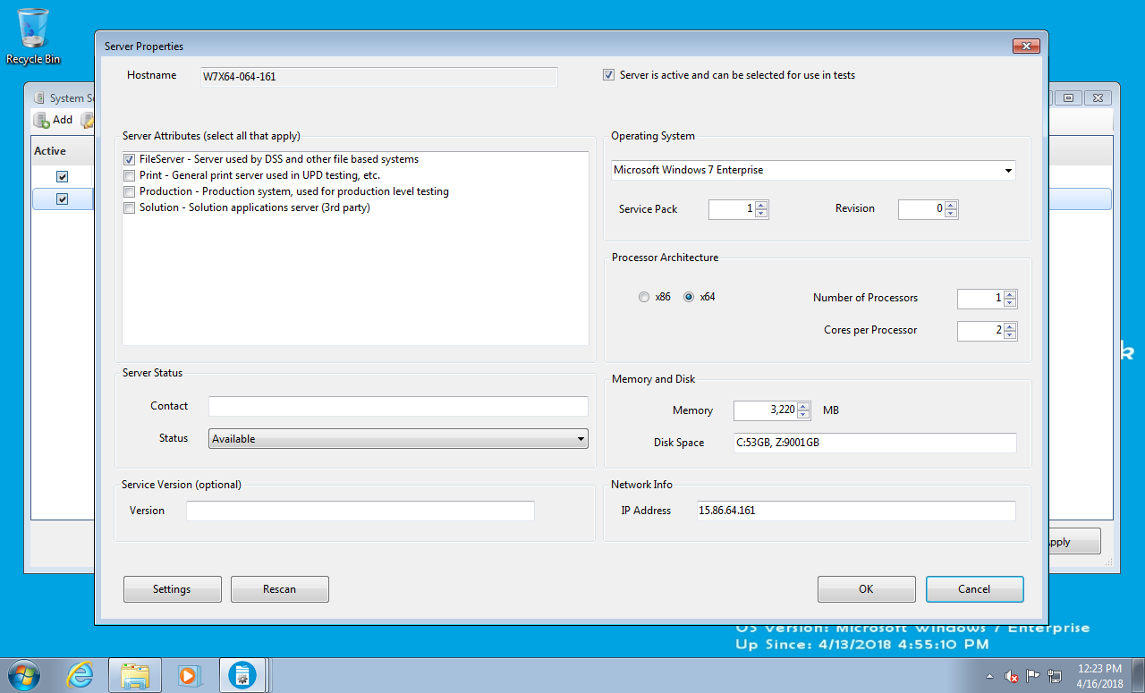
* Add any desired User Pools through the “Virtual Worker Account Pools” link in the STB Admin Control Panel. User Pools allow STB to test switching users on a device, and contention of several users trying to use a device at the same time. For Resource Profiling, at least one User Pool with a range of at least 4 members is required.
* Add corresponding users and credentials to support any added User Pools in the Authentication or Active Directory servers used for the tested Solution. The required settings are highly dependent on the Solution being tested. These need to be made before testing is done, so that as STB executes transactions on the device using the usernames and passwords/PINs configured in STB and the User Pool, the submitted credentials allow a successful authentication of the Virtual Tester on the Solution under test.

## Outline of Documentation for each Supported Automation Capability

For each type of supported automation, the remaining sections of this document describe at a high level how to:

* Import Plugins and Scenarios.
* Configure those Scenarios.
* Execute those Scenarios.
* Run reports on test results, and also to share with ACT.

# Automated Duration Reliability Tests

HP is providing STB Plugins and Scenarios for Solutions that are required to meet ACT Duration Reliability Requirements.

Please consult your ACT Documentation for guidance on how to:

* Choose a representative device set on which to execute Automated Duration Reliability tests.
* Understand for each class of device how many transactions are required to demonstrate reliability.
* Understand the 2 ACT requirements for Solution Reliability.
* Calculate a Mean-Time-Between-Failure for each of the 2 requirements.
* Determine if your test results “pass” or “fail” to meet the ACT Reliability Requirements.

## Importing Automated Duration Reliability Plugins and Scenarios

When the above pre-requisites are finished:

* Add the HP provided Plugins for your Solution. Please see the “Adding Plugins to STB” instructions in the “HP Solution Test Bench - STB Plugin Developers Guide.pdf”. In addition to copying the Plugin assembly (“Plugin.*.dll”) to the STB server and using “Activity Plugin References” through the STB Admin Control Panel to add the Plugin(s) to the STB database, the assembly must also be copied to each STB Client if that Client is installed separately from the STB Server. Note, depending on the version of STB used, the folder path to which the Plugin assemblies must be copied may vary. Users of newer versions should look for the C:\VirtualResource\Distribution\Plugin path.
* Choose which Test Scenario(s) to import. For each class of device, ACT Documentation will indicate the number of transactions required to demonstrate the required level of reliability. The HP provided Scenarios indicate in the stbs file name which number of transactions they are configured to execute.
* Import the required Test Scenarios using the STB User Console (i.e. Client.)
  + Use the menu item “File 🡪 Import Scenario” or right click on any folder in the left hand Navigation pane and select “Import”.
  + Follow the dialogs to browse to the file location of the Test Scenario, select the appropriate file (*.stbs), determine which user groups may use the scenario (default: everyone), and if desired change the folder where the scenario will be placed.

## Configuring Automated Duration Reliability Scenarios

Once the Scenario is imported, it will have to be configured. You may execute the following steps in many different orders, but they all must be completed before executing:

* Click on the imported Scenario. STB displays the “Scenario Configuration” dialog in the right hand pane. Use “Device Bulk Edit” to assign a new device from your asset inventory. This device must have previously added via the “Print Device Inventory” link in the Admin Control Panel.
* Change the ‘User Pool’ on the “User Account” tab of the “Solution Tester Configuration” dialog. NOTE: the ACT Certification requirements require automated testing with 4 distinct users and credentials, switching between the different identities. Therefore, the Duration Reliability Scenarios must be executed with a User Pool with a range of at least 4 users. STB will create at least 4 Virtual Solution Testers. This is indicated on the Scenario Configuration dialog in the “Count” column (see example from Safecom below.)
* Also on the “User Account” tab of the “Solution Tester Configuration” dialog verify that for the two radio buttons at the bottom of the dialog, that “Run the Solution Tester process using the same account selected above” is selected. This is necessary for STB to use the User Pool setting you configured in the previous step.  
  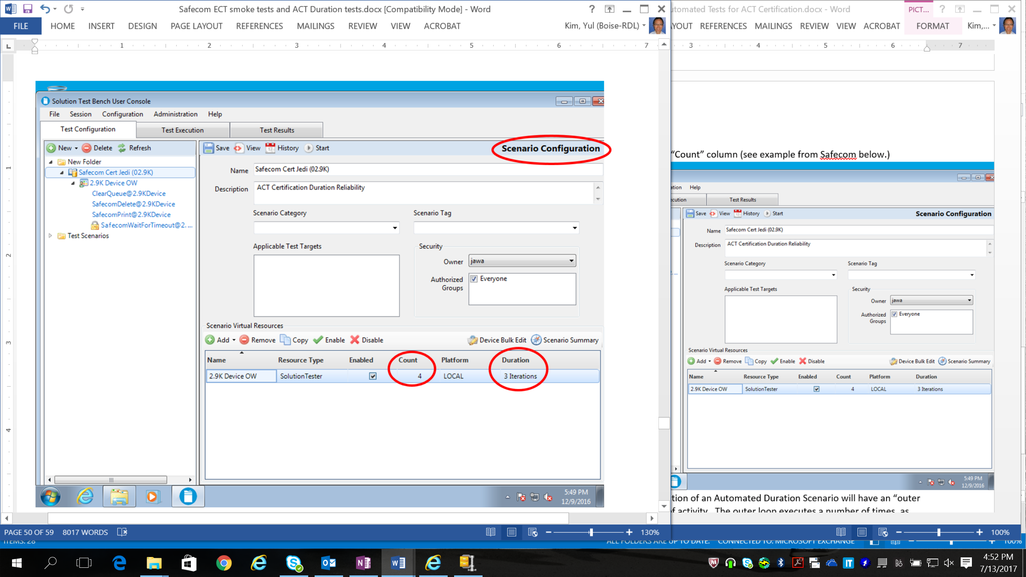

Typically a successful execution of an Automated Duration Scenario will have an “outer loop” and an “inner loop” of activity. The outer loop executes a number of times, as indicated on the Scenario Configuration dialog in the “Duration” column as a number of iterations (see example from Safecom above.)

At the next level down in the left hand navigation pane, on the Solution Tester Configuration dialog, you can see both where the # of iterations and the Solution Testers Count are specified. Again, below is an example for Safecom.  
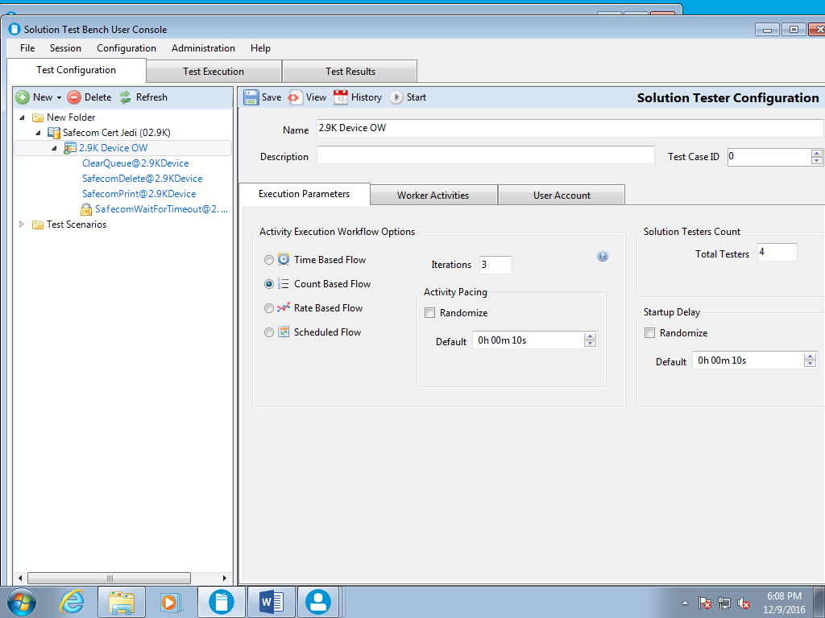

The above screen shot shows the “Execution Parameters” tab. The “Worker Activities” tab shows something like the Safecom example below. Note, that some of the activities have a Run Count. In the example below, each of the 3 Outer Loops executed will in turn execute 40 “Delete” activities, 41 “Print” activities, and 1 “WaitForTimeout” activity. To pass the ACT Requirement, the # of iterations and activities encoded in the Scenario must be executed. For debugging and for trial runs, the tester may change the # of Iterations, and the #s of Run Counts to fit the tester’s needs. However, to pass the ACT Requirements, a run must be done with the pre-programmed # of Iterations and Run Counts. It is therefore suggested that any changes to these parameters be done in a copy of the HP provided Scenario so that the original numbering is retained in one Scenario that can be run to meet ACT Requirements.  
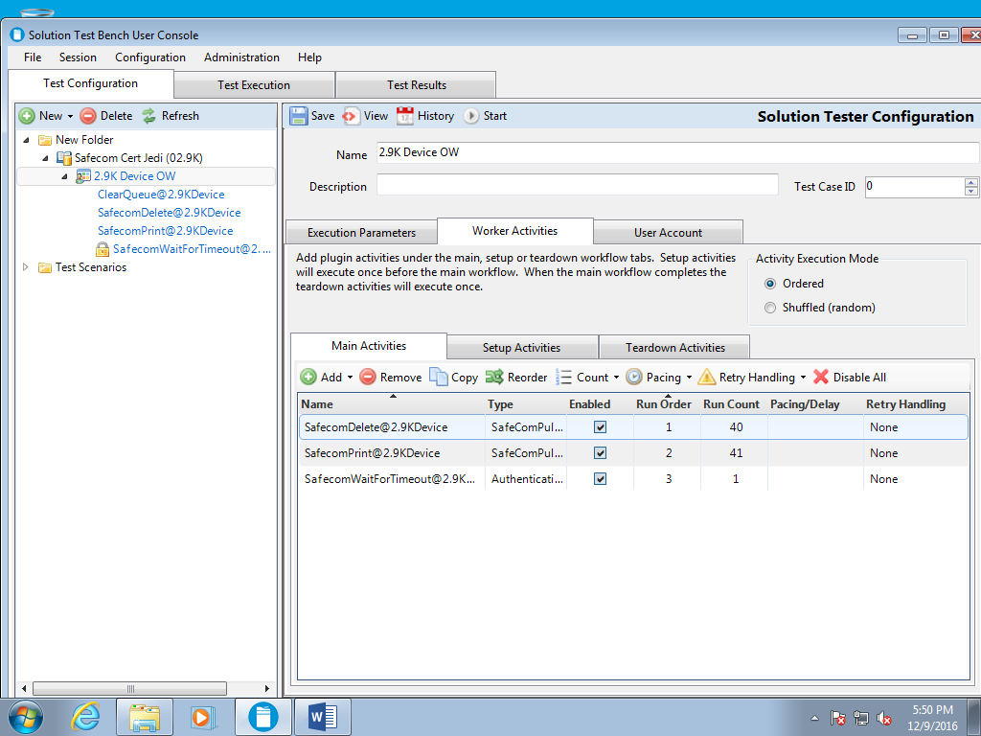

* Click on each of the activities in the left hand pane. Each will need to be configured as follows:
  + If Device Bulk Edit was not previously done, do that now or individually select a device for each sub tab for each activity in “Device Configuration”. There is both a “Pull Printing” sub tab and a “Printing” sub tab.
  + On the “Printing” sub tab, add a print queue through the “Remote Queues” button.
  + On the “Printing” sub tab, ensure that a test document selected (i.e. checked) in “Document Selection”.
  + For the “WaitForTimeout” activity, there should be a device selected.
  + For the “WaitForTimeout” activity, check and verify that the setting for “Unauthentication Method” is set to “Wait For Inactivity Timeout”, then Save.

## Executing Automated Duration Reliability Scenarios

Be sure to save any changes to your Scenario. STB will prompt you to save if you switch to another dialog.

To execute the scenario, click on the “Start” button in the header.

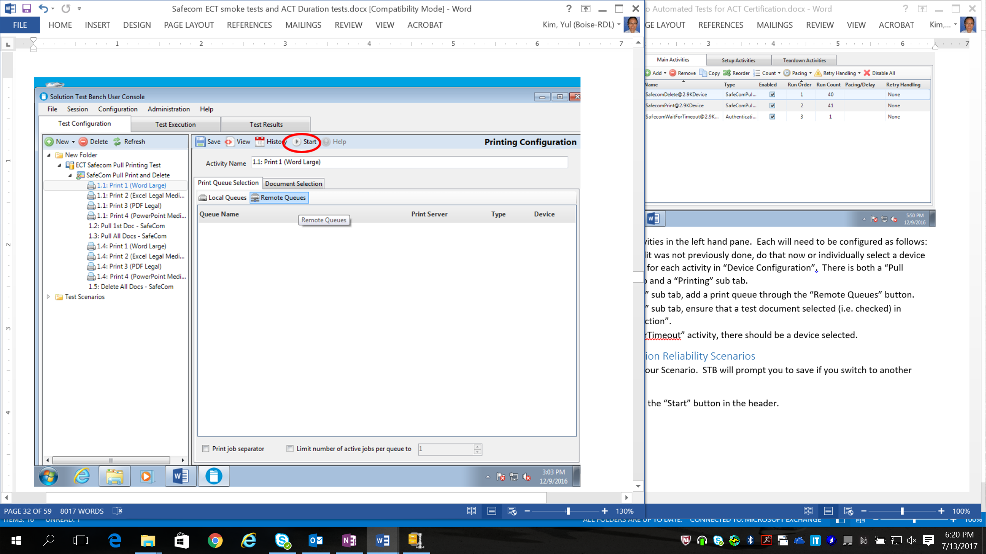

There is an issue that if the estimated execution time for a scenario is exceeded, STB may error out because it may assume that the reservation for a device has expired. Until this issue is fixed, to be safe, configure the “Estimated Runtime (hours)” to be well above the amount of time you expect the test to run (see below.) Also, remember to change the “Log Retention” setting to greater than 1 Day if you are troubleshooting so that logs can be retained if needed for troubleshooting help.

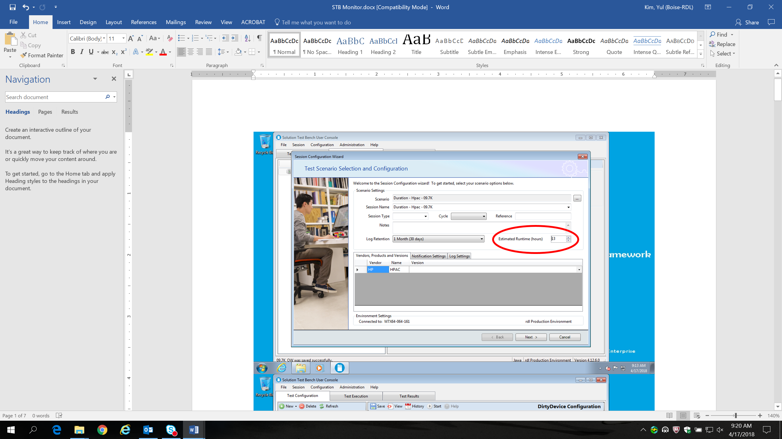

It is strongly suggested to use the default setting of “Paperless Mode”. If Paperless Mode is NOT selected, the device’s output bin may fill up and the test will pause.

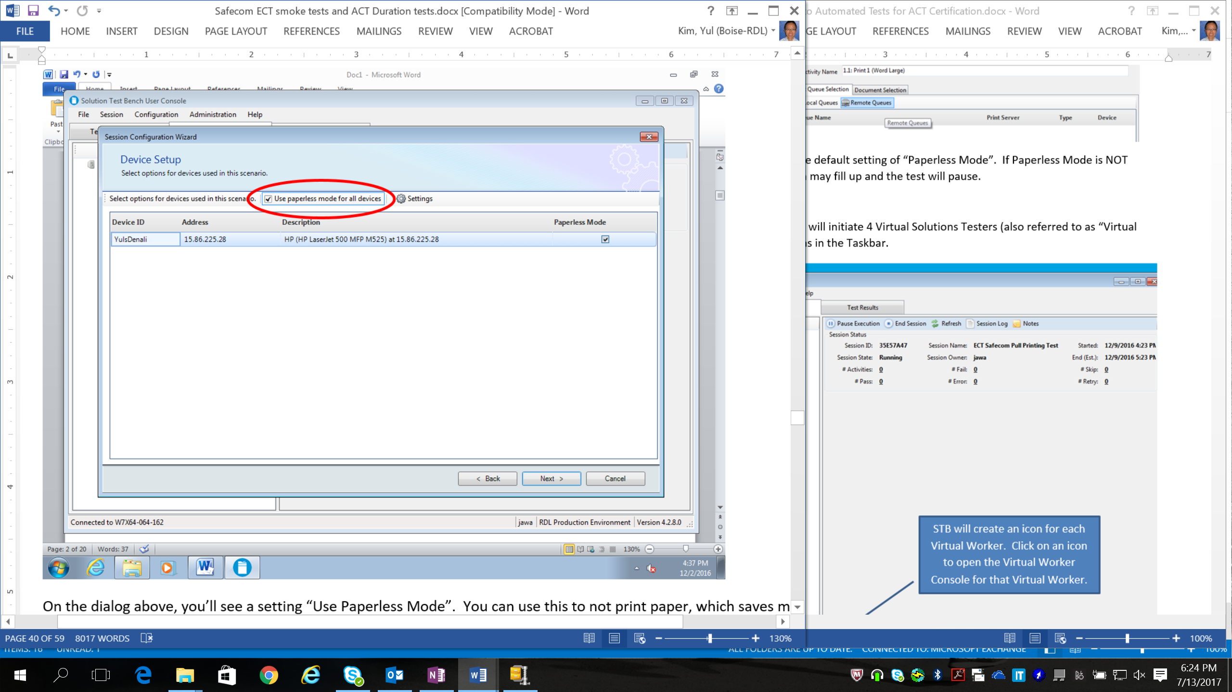

After the Scenario starts up, STB will initiate 4 Virtual Solutions Testers (also referred to as “Virtual Worker”). These will create icons in the Taskbar.

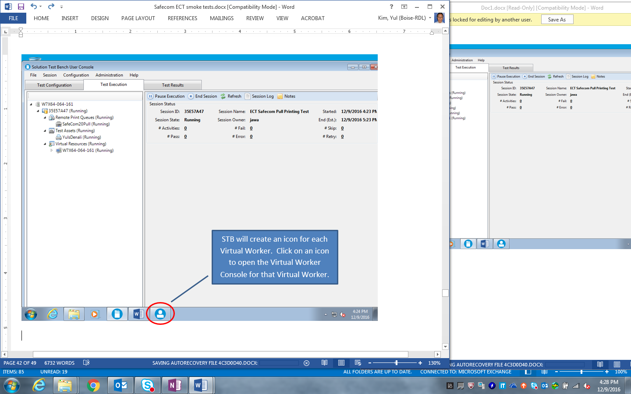

If you click on any Solution Tester icon, you will see something like the dialog below. The activities from the “Worker Activities” tab will be listed in order from Left to Right as tabs. The lower pane, the “Worker Activity Log”, will show the higher level start and end of each Worker Activity. The upper “Execution Status” pane shows the details of each individual activity.

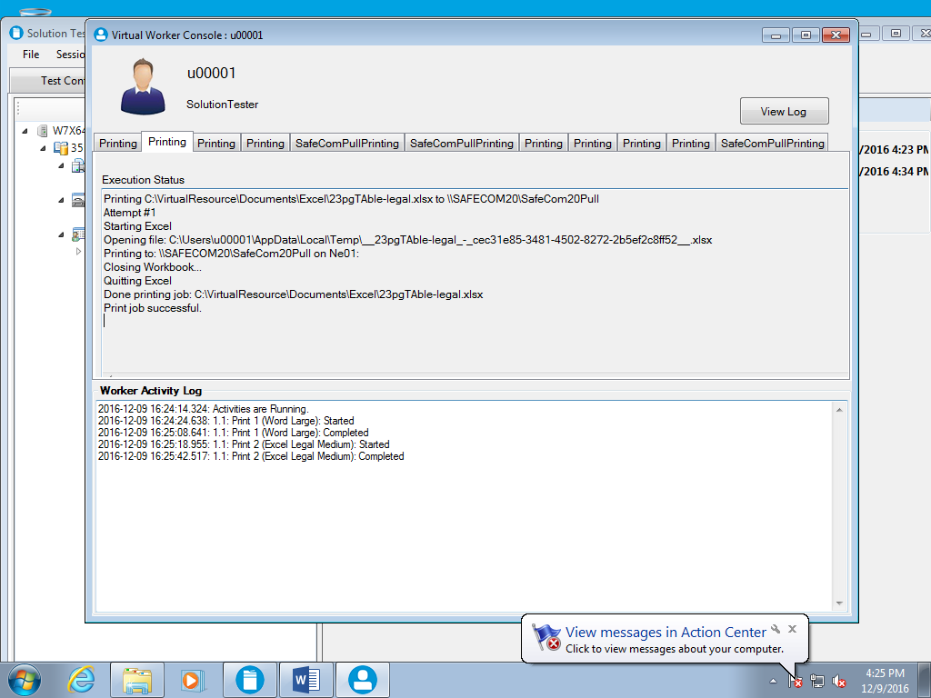

The Test Results tab has a number of charts that show activity while it happens. Make sure your current Session is shown in the drop down list, and click the “Refresh” button to get the current status. An example of the Test Results tab is shown below.

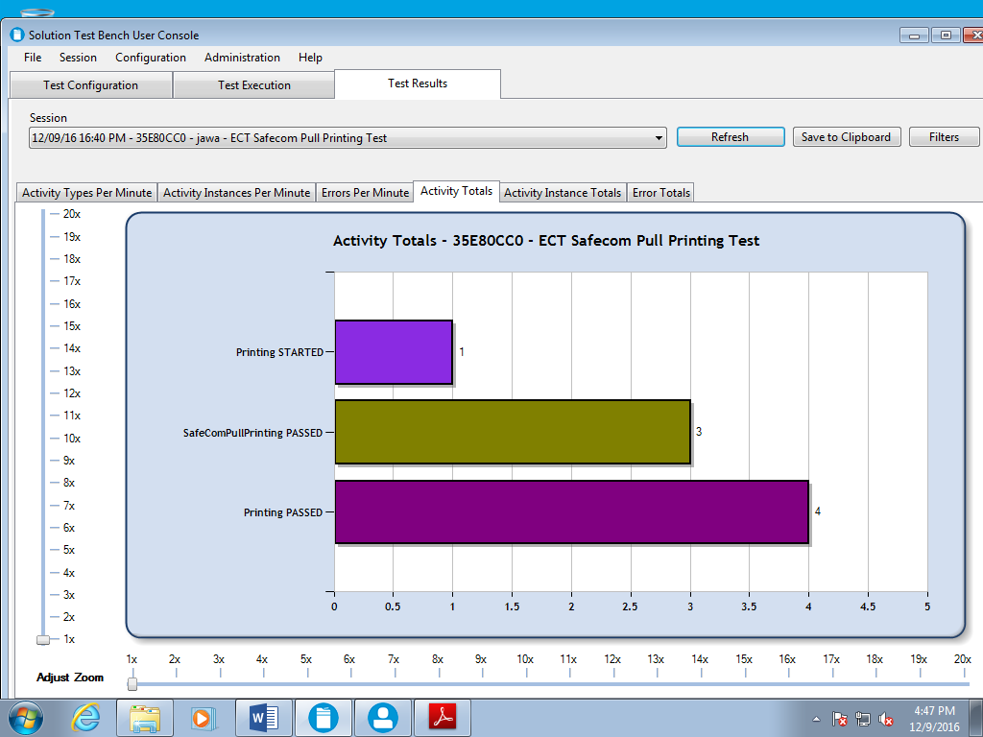

Failures will appear in the execution status graphs shown on the Test Results tab, and will appear as they happen for each Virtual Tester in both the “Execution Status” and “Worker Activity Log”.

After execution completes, use the “Session Shutdown” dialog to reset the system to a known state. Typically the default settings are sufficient to clear any pending activity that was not completed at the device.

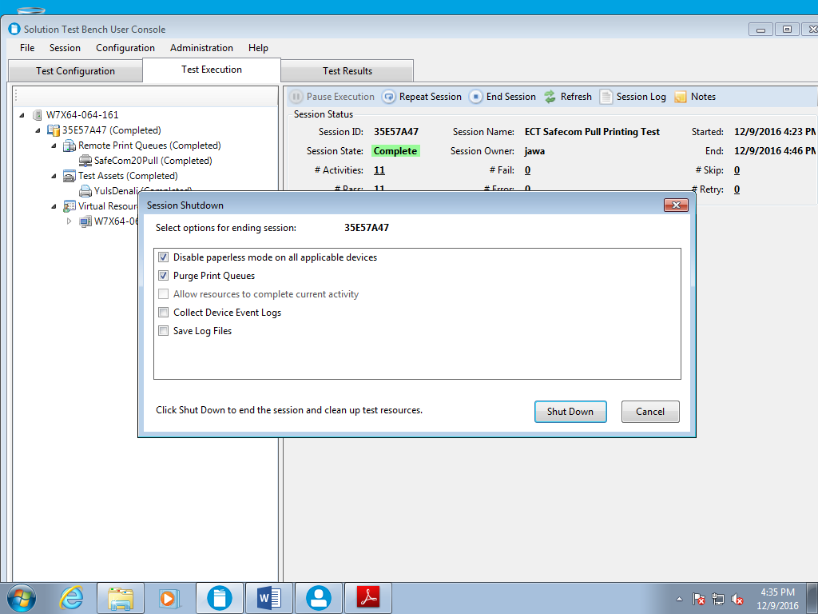

## Generating Reports for Automated Duration Reliability Testing

After execution finishes, you can run reports. From the User Console, select the Session menu, then Session Reports:

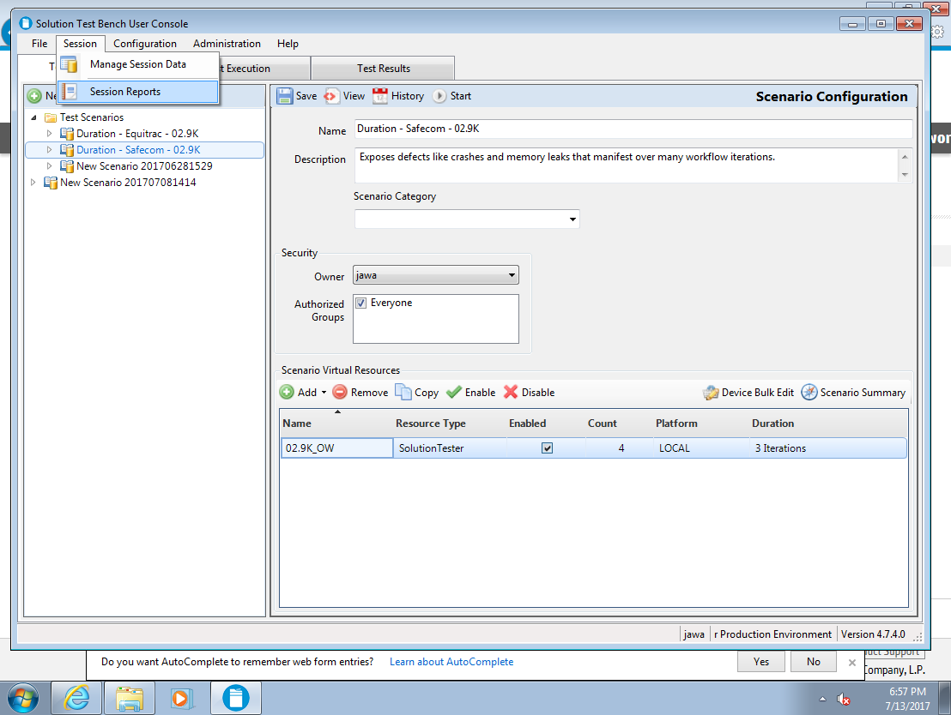

Then select the session for which you wish to generate the report from the list of sessions, and then click the “Browse” button to select an Excel report. In the example below, “Activity Details.xlsx” is being selected. Click Open and then “Generate Report”. Excel opens with the report. The report has over a dozen graphs and pivot tables that you can modify as you wish. Save to save the report to your VM or PC.

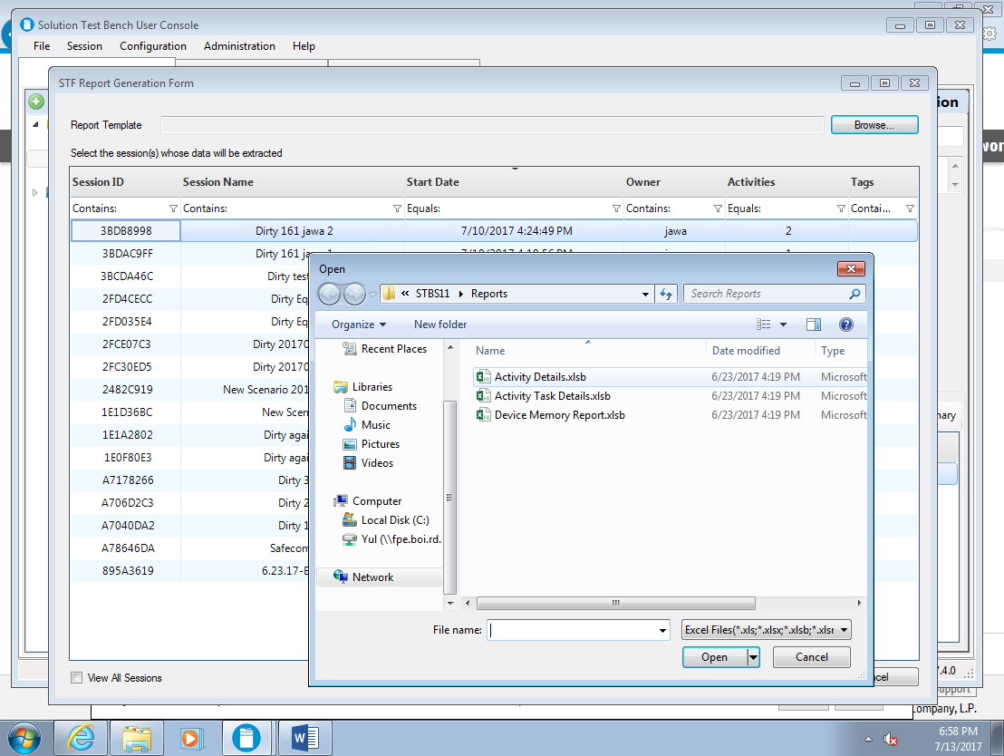

The potential for creating custom Excel reports is wide open. Anyone may create new reports, place them in the correct path (there are variations depending on the original STB version installed although whatever path is shown when browsing for a report is the correct path) and then the report appears in the list of reports to run.

If the Excel spreadsheet appears to be empty of data, you may have to click first on “Enable Content” (which may appear as a “Security Warning” banner in Excel) and then on the Data menu, “Refresh All”. We recommend clicking Save immediately in Excel to retain the refreshed data.

Shown below is the Data tab of the “Activity Details” report, which lists all of the activities that executed in that session:

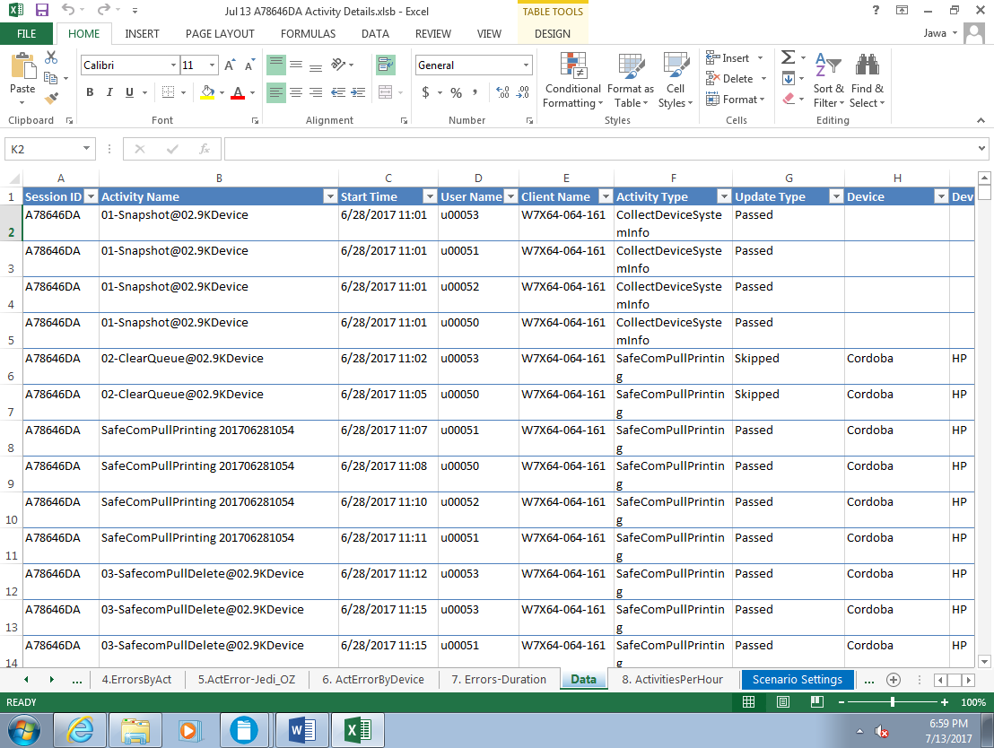

Instructions on how to calculate pass or fail for automated duration are included in ACT documentation, in the form of detailed step by step worksheet. Use the pass/fail statistics reported by STB, either through the UI or one of the Excel reports, to calculate the failure rate for the 2 ACT Requirements. “Skip” does not count as a failure. “Error” is typically a tooling issue. “Fail” counts as a failure for calculating the failure rates.

# Automated Support for Resource Profiling

## Resource Profiling Overview

Resource Profiling is required for ACT Certification and HP Branded OEM Solution Qualification. Resource Profiling is required on both FutureSmart 3 (Windjammer) and FutureSmart 4 (Omni) devices. STB 4.7.5.0 and higher have automation support for FutureSmart 4 Resource Profiling. HP is not distributing formal STB support for Resource Profiling on FutureSmart 3 to Partners at this time.

There are several changes in Resource Usage Requirements with FutureSmart 4 / Omni. Please see ACT documentation for the requirements for FutureSmart 4 Resource usage by Solutions.

ACT documentation also specifies the process Partners must use to measure and calculate Resource Usage of their Solutions. The calculation is a difference, between the native device’s usage and the usage of the Solution running on top of the device. Because the calculation is a difference, a baseline usage measurement must be done first for native functionality. The process of exercising the native functionality of the device to get to a representative level of resource usage for native features is referred to as “dirtying”. The dirtying activity increases the resource usage of the device from a “clean” level after device boot to a level representative of typical usage of native features on the device (i.e. dirty.) Next, the device is exercised again, this time with representative Solutions workflows (native workflows can also be executed, and even if they are not explicitly invoked, resources will be invoked by native areas of the code to support solutions workflows that do print, scan, etc.) Finally, a measurement is done after BOTH native functionality AND representative Solutions workflows have been executed. The Solutions usage is then calculated by subtracting the first measurement from the second measurement.

In STB 4.7.5.0 and higher, the dirtying process is automated using the “DirtyDevice” plugin (which also has a dependency on another plugin, “DeviceUtility”.)

In STB 4.7.5.0 and higher, there is also a plugin “CollectDeviceSystemInfo” available that takes a resource usage snapshot.

HP is providing STB Scenarios for the following solutions: HP Access Control, HP Capture and Route, Nuance Safecom, Nuance Equitrac, Pharos Blueprint, and Papercut MF. These scenarios make use of the DirtyDevice and CollectDeviceSystemInfo plugins.

Other Solutions that wish to measure Resource Usage may use two of these Scenarios because they are generic and are not specific to any Solution.

Measuring Solution Resource Usage on FutureSmart 4 uses the following procedure:

1. Partial clean the device. This ensures the device is at a known and reproducible state.
2. Set device password to match the password used by STB. Usually this is “!QAZ2wsx”. It is configurable through the “DeviceAdminPassword” setting that can be changed through the “Global System Settings” link in the Admin Control Panel.
3. Reboot the device.
4. Capture resource snapshot A.
5. Dirty the device.
6. Capture resource snapshot B.
7. Install the Solution.
8. Reboot.
9. Capture resource snapshot C.
10. Dirty the device.
11. Execute Solution workflows (can be automated or manual)
12. Capture resource snapshot D.

## Automated Resource Profiling with HP Provided Scenarios

With the HP provided scenarios, the steps above convert to:

1. Partial clean the device. This ensures the device is at a known and reproducible state.
2. Set device password to match the password used by STB.
3. Run the SetupOW Scenario, which does:
   1. Reboot
   2. Capture resource snapshot.
   3. Dirty the device.
   4. Capture resource snapshot.
4. Install the Solution.
5. Run the SetupOW Scenario again, which does:
   1. Reboot
   2. Capture resource snapshot.
   3. Dirty the device.
   4. Capture resource snapshot.
6. Execute Solution workflows (can be automated or manual)
7. Run the TeardownOW scenario, which does:
   1. Capture resource snapshot.

Step F above may be automated using STB plugins and scenarios, or may be executed manually. The Partner must execute a set of Solutions Workflows that, based on developer knowledge, gets the resource usage to a steady state of resource consumption on the device. Several HP Branded and HP Sold solutions will have automated plugins provided by HP that can fulfill the activity in Step F. Other Partners may either write their own STB Plugin and execute the Solutions workflows using the resulting automation, OR they may execute Solutions workflows manually. Either way, the dirtying and snapshotting on the device can be done through the available plugins.

If you are not interested in the impact of a Solution install on resource consumption, you can skip Step C. By skipping Step C, you will NOT be able to separate the impact on resource usage of using the Solution versus just installing the Solution. Generally, the impact of install is small and is of less interest than the usage of the Solution.

## Importing Automated Resource Profiling Plugins and Scenarios

Please follow the same instructions in the previous Section “Importing Automated Duration Reliability Plugins and Scenarios”.

## Configuring Automated Resource Profiling Scenarios

Once the Scenario is imported, it will have to be configured. You may execute the following steps in many different orders, but they all must be completed before executing:

* Click on the imported Scenario. STB displays the “Scenario Configuration” dialog in the right hand pane. Use “Device Bulk Edit” to assign a new device from your asset inventory. This device must have previously added via the “Print Device Inventory” link in the Admin Control Panel.
* Set the login credentials of the Solutions Tester(s) on the “User Account” tab of the “Solution Tester Configuration” dialog. Resource Profiling only requires one Virtual Solution Tester, therefore any of the possible options can work. Please verify that for whatever setting is chosen, that the corresponding permissions have been configured for any Solution login, and also for the desired Scan Destination Server configured in the pre-requisites.   
  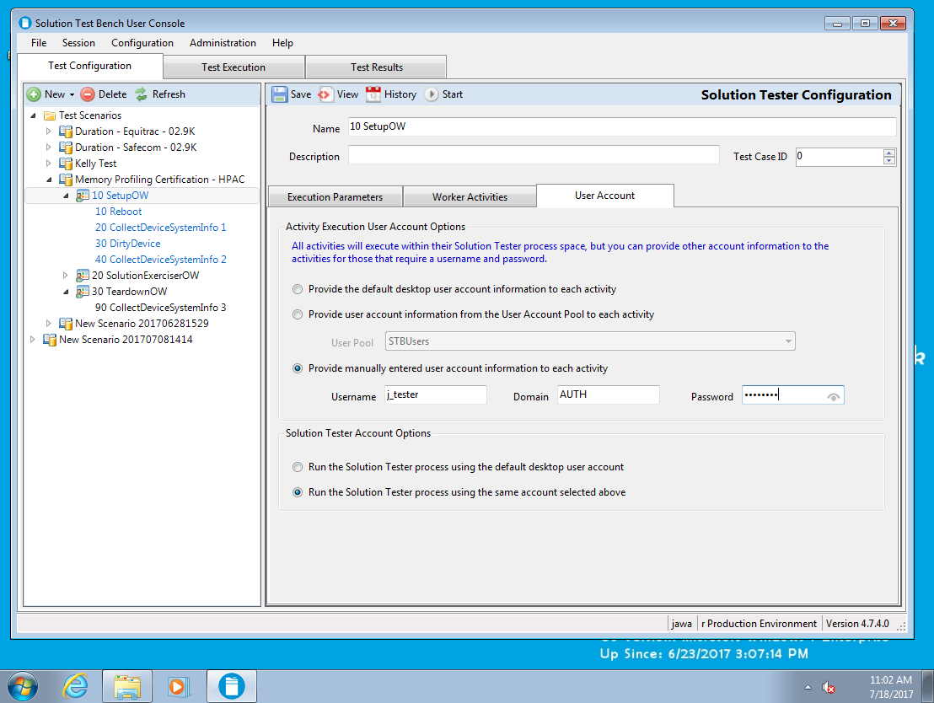
  + Remember, when using the option “Provide the default desktop user account information to each activity” that the login credentials of the user logged into the VM or PC are used to authenticate if required in the test activity. In the example dialog above, this is “jawa” as shown in the field third from the right in the footer status bar of the STB window.
  + The tester may also specify a specific username, domain, and password to be used for this test. In the above dialog, j_tester\AUTH is used as credentials for the Virtual Solution Testers that are created. NOTE, this implies that if more than one Solutions Tester is created, they will have the same identity. If this option is chosen be sure to also select the “Run the Solution Tester process using the same account selected above” radio button in the lower dialog pane. It is NOT the default setting in some STB versions.
  + In some versions of STB 4.7.X, a username jawa and a password!QAZ2wsx may be required. This is a defect but as a workaround if there are permission errors, please add this user to the local domain and try executing with those settings. This issue is NOT present on STB 4.12.X.
  + Make sure the screen resolution of the VM or PC where STB is running is at least 120 x 775. Screen resolutions of 1152 x 864 or 1142 x 774 or less will cause a failure during the “Dirty EWS” activity. The Dirty EWS activity opens a browser on the test VM or PC and clicks on a variety of EWS links, and at lower resolutions the Networking tab is NOT visible in a browser window.
* Click on each of the activities in the left hand pane. Each will need to be configured as follows:
  + If Device Bulk Edit was not previously done, do that now or individually select a device for each activity. The Reboot, CollectDeviceSystemInfo and DirtyDevice activities only have a single sub-tab.
  + For the DirtyDevice activity, select a device if you have not done that already.
  + For the DirtyDevice activity, make sure all of the Plugin Actions are checked, as shown in the dialog below.
  + The DirtyDevice activity in the “Dirty DigitalSend” activity will scan and transmit that scan file to ftp, http, and folder. If the Solution does NOT have a scan feature (for example, is ONLY a Pull Print or Security Solution,) it may be possible to skip this step. You can uncheck “DirtyDS” in the DirtyDevice Configuration dialog (see example below):  
    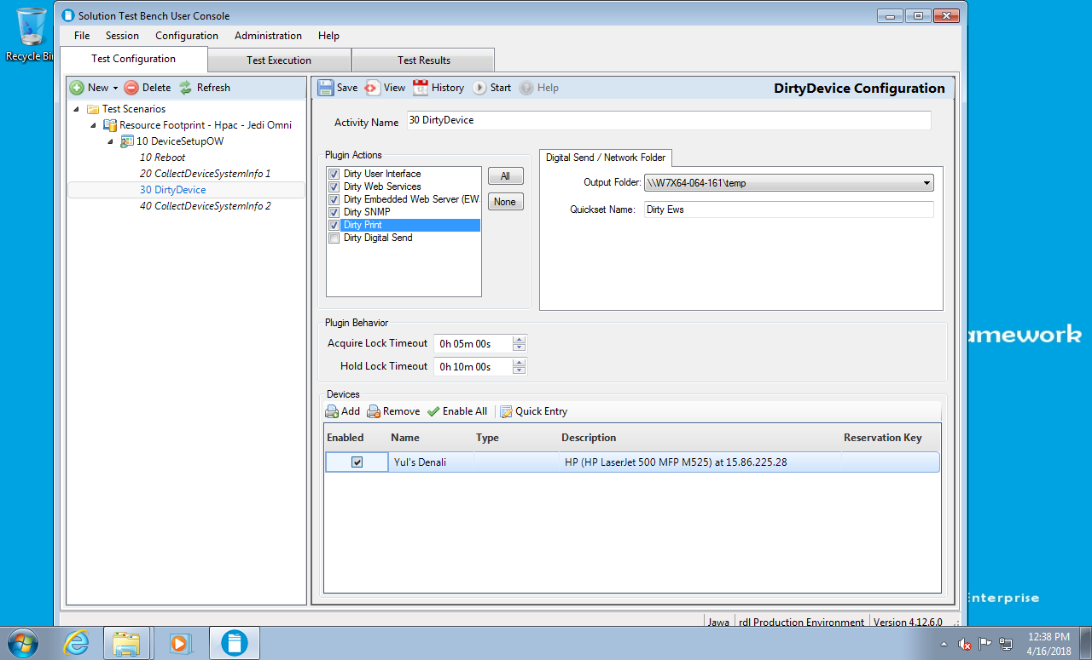
  + If your solution scans, you must execute DirtyDS as part of the dirtying process. Configure the test machine in use with an FTP server. The instructions below provide the basic steps to configure an FTP server on your test machine. For additional reference see: <https://www.windowscentral.com/how-set-and-manage-ftp-server-windows-10> .
    - Create a shared folder on your test machine. There is a current limitation in STB that the FTP destination must be on the same computer or VM as the User Console being used. The shared folder path must match the path implied by the STB Monitor Configuration previously configured (see “STB Pre-requisites”).
    - Make sure the folder is shared with access for Everyone. For example, the path \\W7X64-064-161\temp would have these permissions:  
      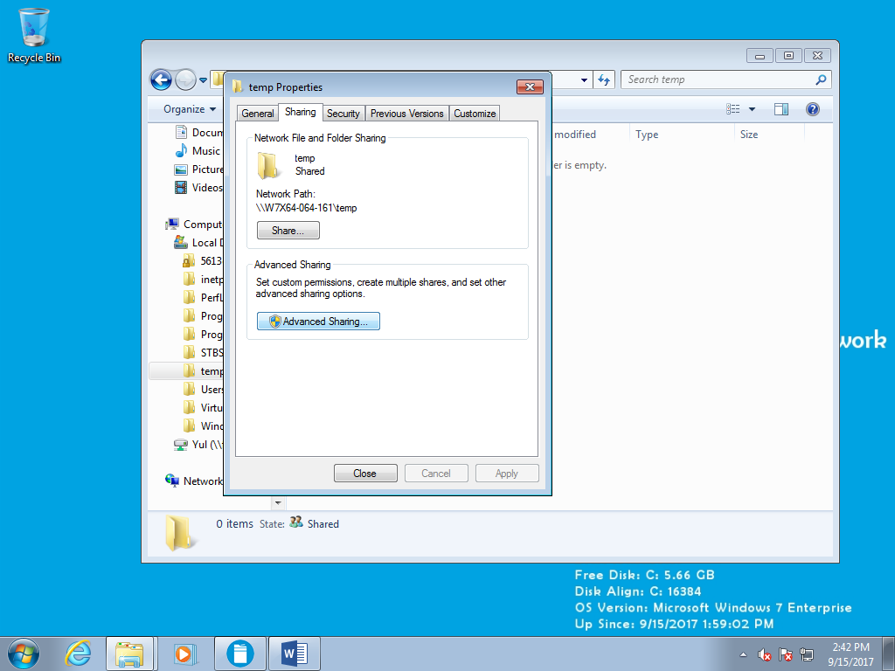 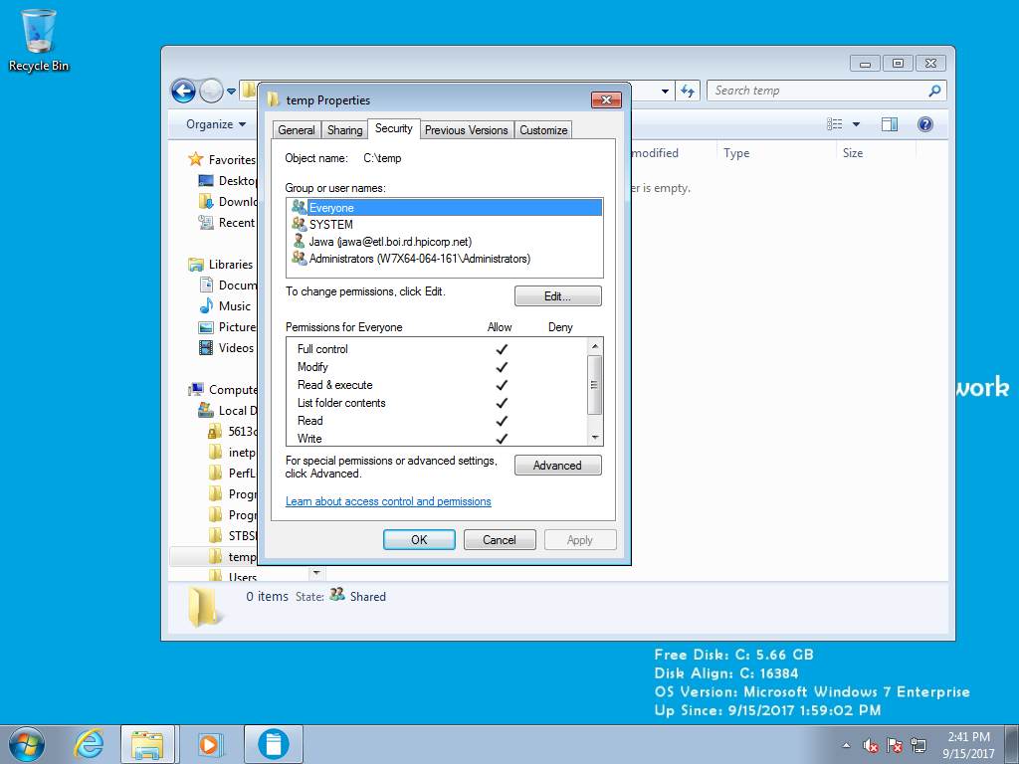
    - Use the Windows Control Panel (“Programs” or “Programs and Features” 🡪 “Turn Windows features on or off”) to enable IIS and the FTP service (see below):  
      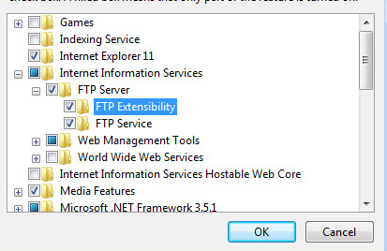
    - Also, turn on the IIS Management Console:  
      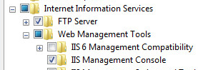
    - Open IIS Manager and add an ftp site. Set the “Physical Path” for the FTP site to the shared folder defined above:  
      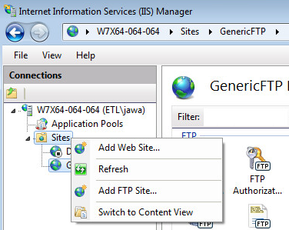
    - When adding the ftp site, make sure SSL is set to “No SSL”. The settings below are recommended:  
      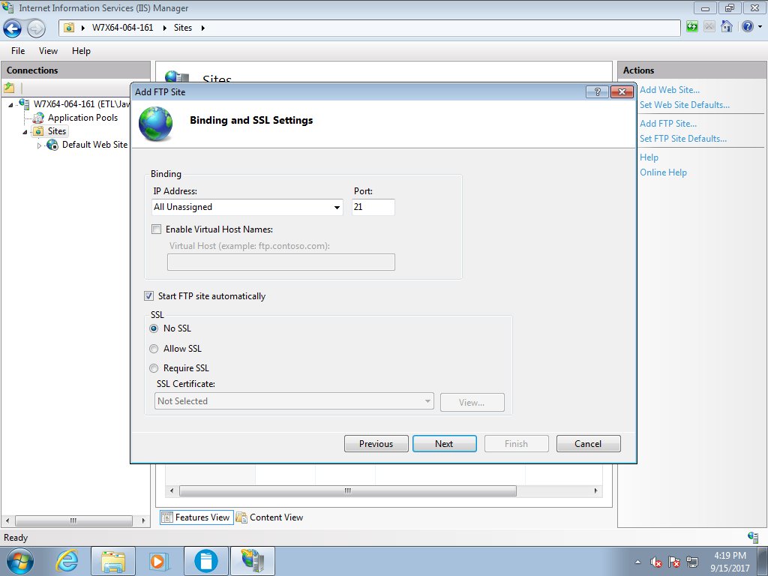  
      Also, ensure that both Anonymous and Basic Authentication are enabled, and that permissions are set Read/Write for All Users:  
      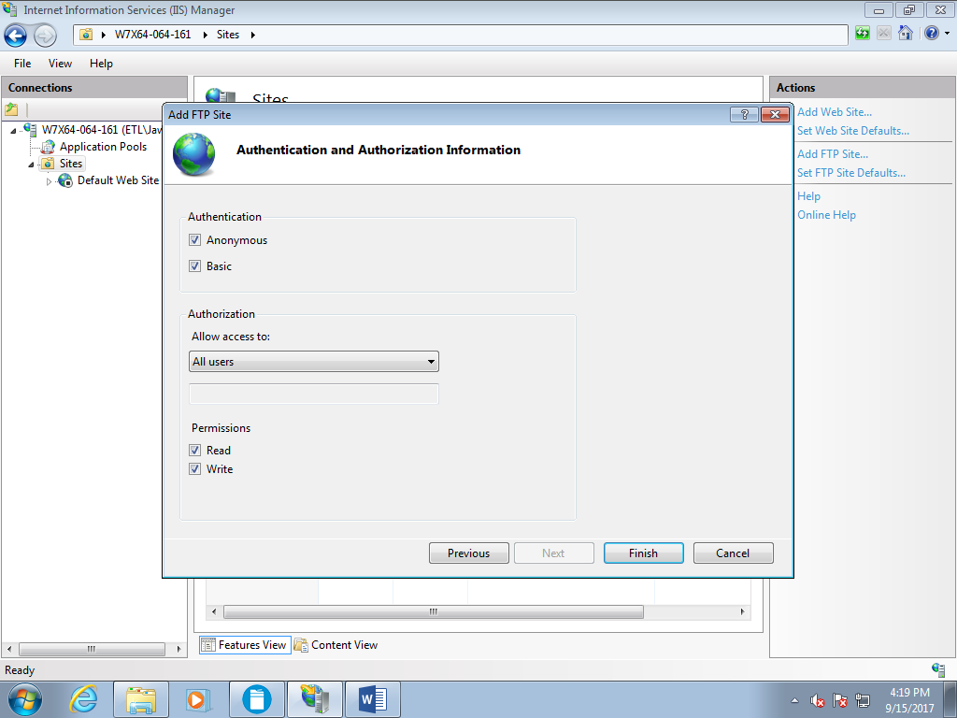
    - NOTE: in setting up the ftp site, the settings above are configurable. They are also configurable after the FTP site is created through IIS Management Console.
  + DirtyDS will also send to a network folder. Create and share a folder on the server that will be the destination. Share the folder to Everyone, or to the usernames of the UserPool you are using. If you followed the steps in the previous section “STB Pre-requisites”, the VM or PC where STB is installed has already been added via the STB Admin console to the list of servers that STB is aware of. In the example below, “temp” has been created and is shared with the UserPool u00021-u00026:  
    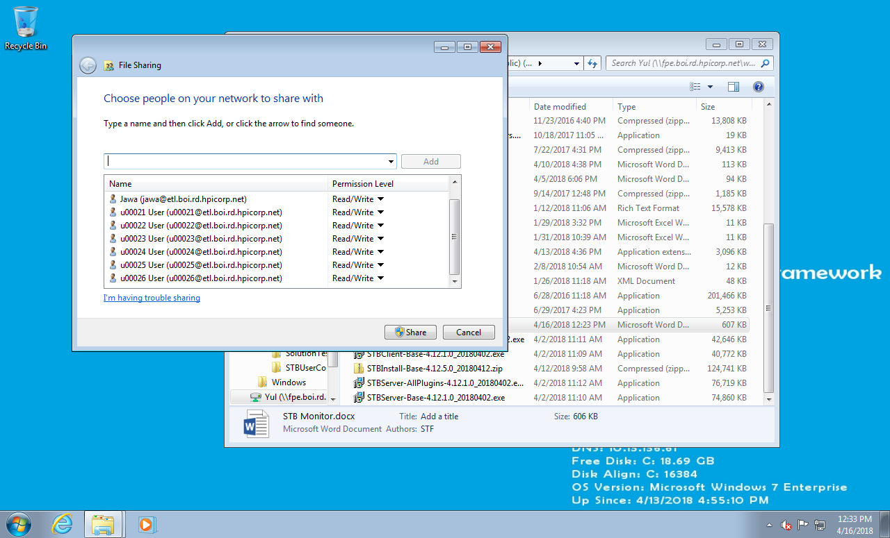
  + Now add the shared folder as a Scan Destination through the Configuration menu in the STB User Console, under the menu item “STB Monitor Configuration”. Choose “Output Directory” and then type in the folder path of the shared folder you created in the step above (see the example below, which uses the folder “temp”):  
    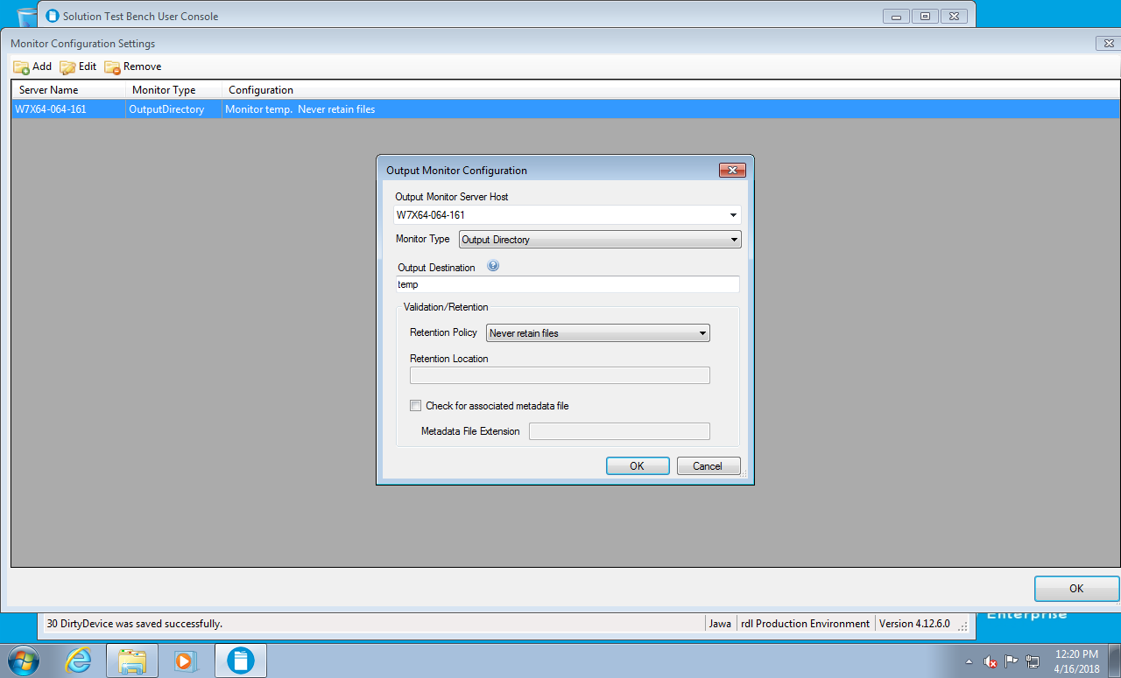  
    NOTE, in the example above, the share path would be \\W7X64-064-161\temp.
  + Back in the plugin configuration “DirtyDevice Configuration”, in the “Digital Send / Network Folder” sub-tab, select an “Output Folder”. The folders listed in the drop down are the destination folders previously defined through the “STB Monitor Configuration” dialog. Again, the paths for the shared folder on the test computer/VM and the STB Monitor Configuration dialog must match, and it is suggested that the ftp site defined through IIS also match.  
    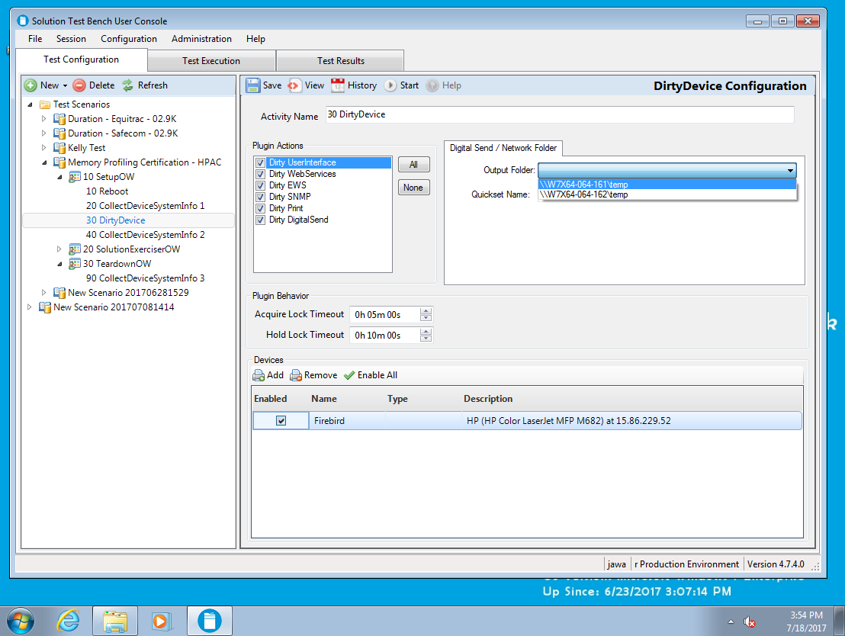
  + The “Digital Send / Network Folder” dialog specifies a “Quickset Name”, which is automatically populated with “Dirty Ews”. This is the name of the Quick Set that the DirtyDevice plugin will use on the device control panel to exercise the device’s native Digital Send capabilities. The “Dirty EWS” action, which is executed before the Dirty DigitalSend action, will create the “Dirty Ews” QuickSet on the device with the destination network path selected in the “Output Folder” drop down list.
  + Check the “Hold Lock Timeout” setting (see dialog above.) The default is 10 minutes. It is a good idea to increase this to about 25 minutes or as needed if the speed of your computer/VM running STB is poor.
* If HP has provided a Scenario with Solution specific automated workflows (HP AC, HP CR, Safecom, Equitrac, Pharos, Papercut) then also click on each activity in the left hand pane and configure the following:
  + If you did not previously run “Bulk Edit”, run that now or select and save a device for any ClearQueue, PullDelete, or PullPrint activity.
  + If there is a “Printing” sub-tab, select a Remote Queue and verify that a document is selected in the “Document Selection” portion of the dialog.
* Please look again at the sub-section “Automated Resource Profiling with HP Provided Scenarios”. Step C (“Run the SetupOW Scenario”) could be executed as shown below. Since Step C measures before the Solution is installed, you will note that it is ONLY executing SetupOW and that SolutionExerciserOW and TeardownOW are NOT checked. As previously stated, if you are not interested in assessing the impact of a Solution install on resource consumption separately from actively using the Solution, you can skip Step C.  
  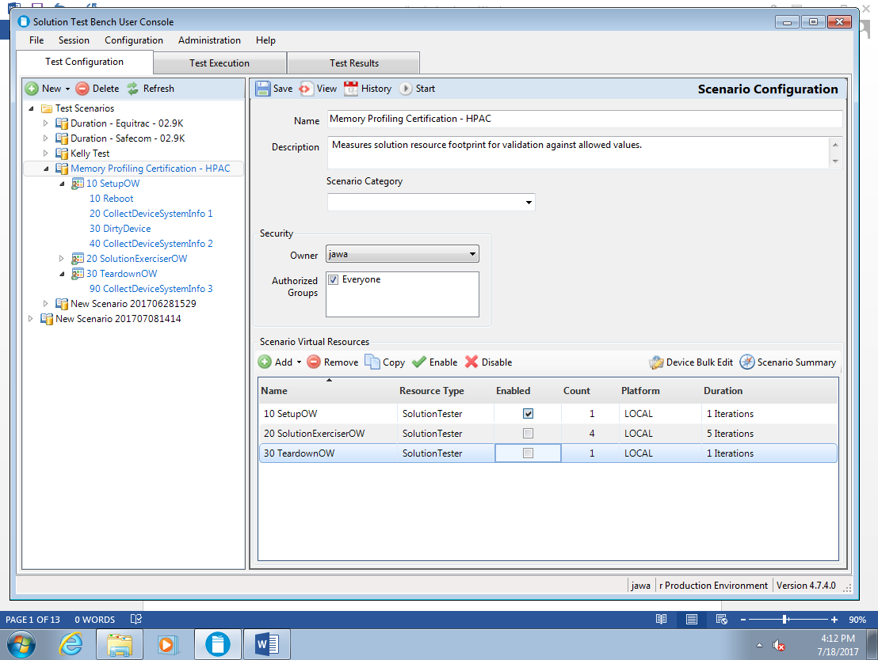  
  Steps E – G could be executed as shown below. Note, SolutionExerciserOW uses an STB plugin to automate the activity of the Solution. If there is no plugin for the specific solution, and the tester is using STB to automate the dirtying and resource measurement portions of the resource profiling steps, but executing the solution workflows manually, then SetupOW can be run, then solution workflows can be executed manually, and then TeardownOW can be run.  
  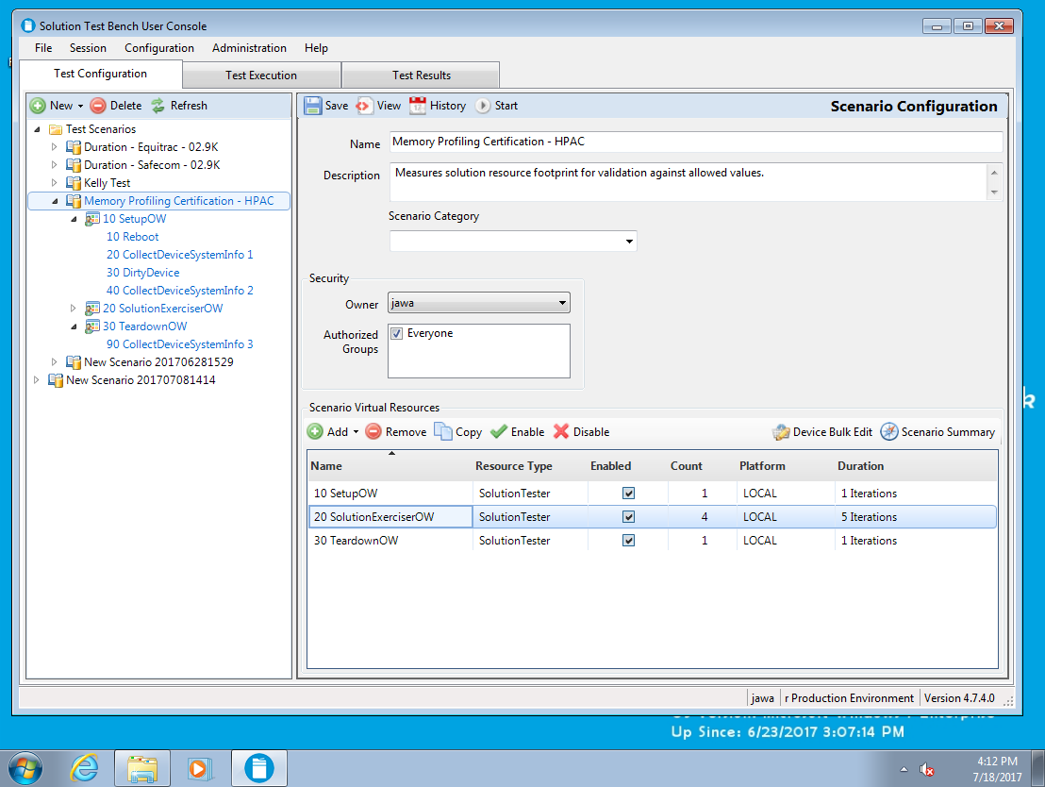

## Executing Automated Resource Profiling Scenarios

Be sure to save any changes to your Scenario. STB will prompt you to save if you switch to another dialog.

To execute the scenario, click on the “Start” button in the header. As stated previously, executing the sequence shown in the section “Automated Resource Profiling with HP Provided Scenarios” automates the majority of the Resource Profiling process. It requires running the SetupOW scenario, then installing the Solution on the device, running SetupOW again, executing automated Solution specific scenarios based on STB plugins available for that Solution (or manually executing Solution workflows), and finally running TeardownOW. If the Partner does NOT need to measure the impact of installing a Solution on resource consumption, then the Partner can skip step C of running SetupOW the first time before the solution is installed. The ACT requirements do not include measuring the impact of the Solution install. The ACT requirements DO include measuring the impact of executing Solution workflows (i.e. steps E, F, and G.)

Executing the SetupOW activity requires 20 to 25 minutes.

NOTE: there is a known timing issue with the Dirty DigitalSend portion of the DirtyDevice activity. This may result in an error similar to the following as well as a 404 error to appear on the device. You may ignore the error. The resource dirtying on the device is still accomplished.

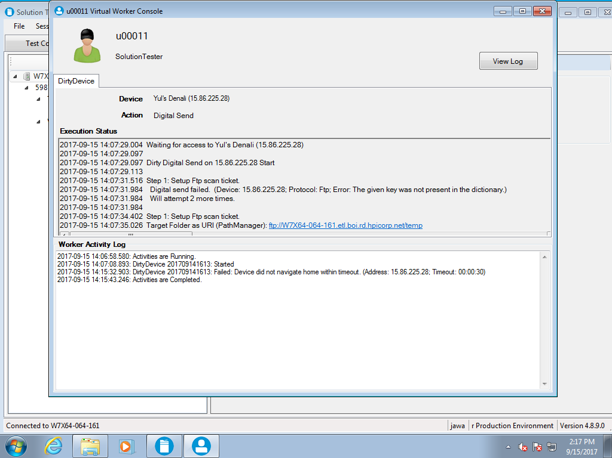

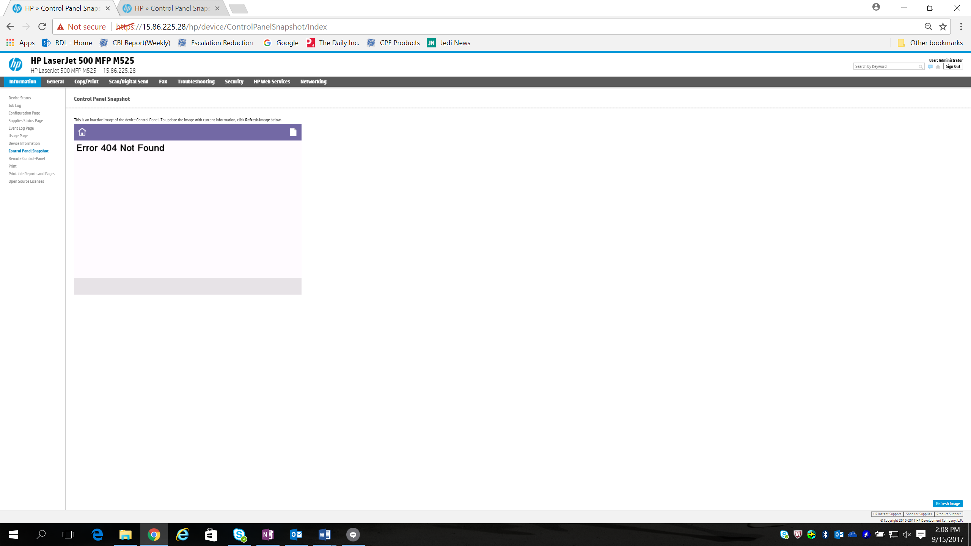

When execution completes, check for errors (the above exception is allowed.)

Again, check the ACT requirements for how to interpret Resource usage results. To get Resource usage metrics from the snapshots that are taken:

* In the STB User Console, select the “Session” menu and then “Session Reports”.
* Select the Test Session for which you want Resource usage data.
* Click the Browse button and select the Excel report “Device Memory Report”.
* Save the resulting Excel spreadsheet.
* Open the Excel spreadsheet.
* Depending on the settings on your PC, you may have to click the “Enable Content” button:  
  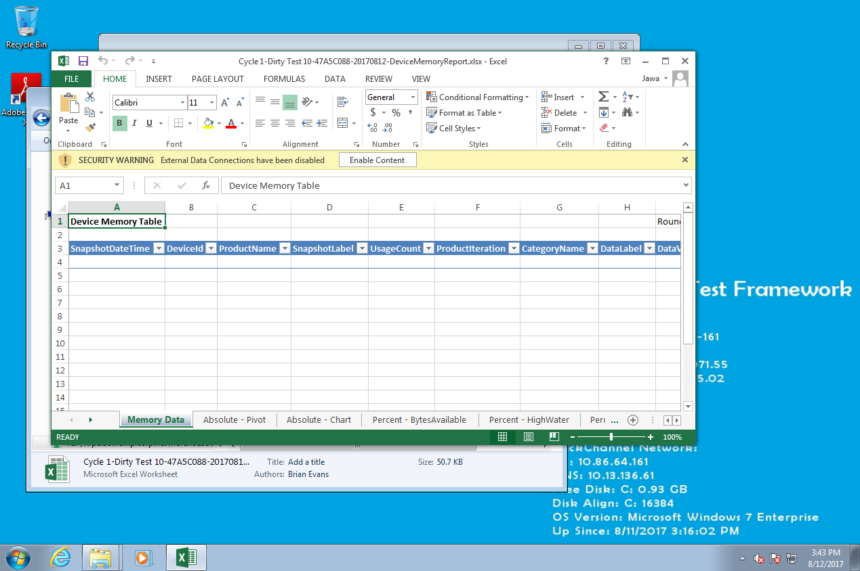
* Then select “Refresh All” from the Data menu. The Excel spreadsheet needs to be on the same PC as the STB Server install:  
  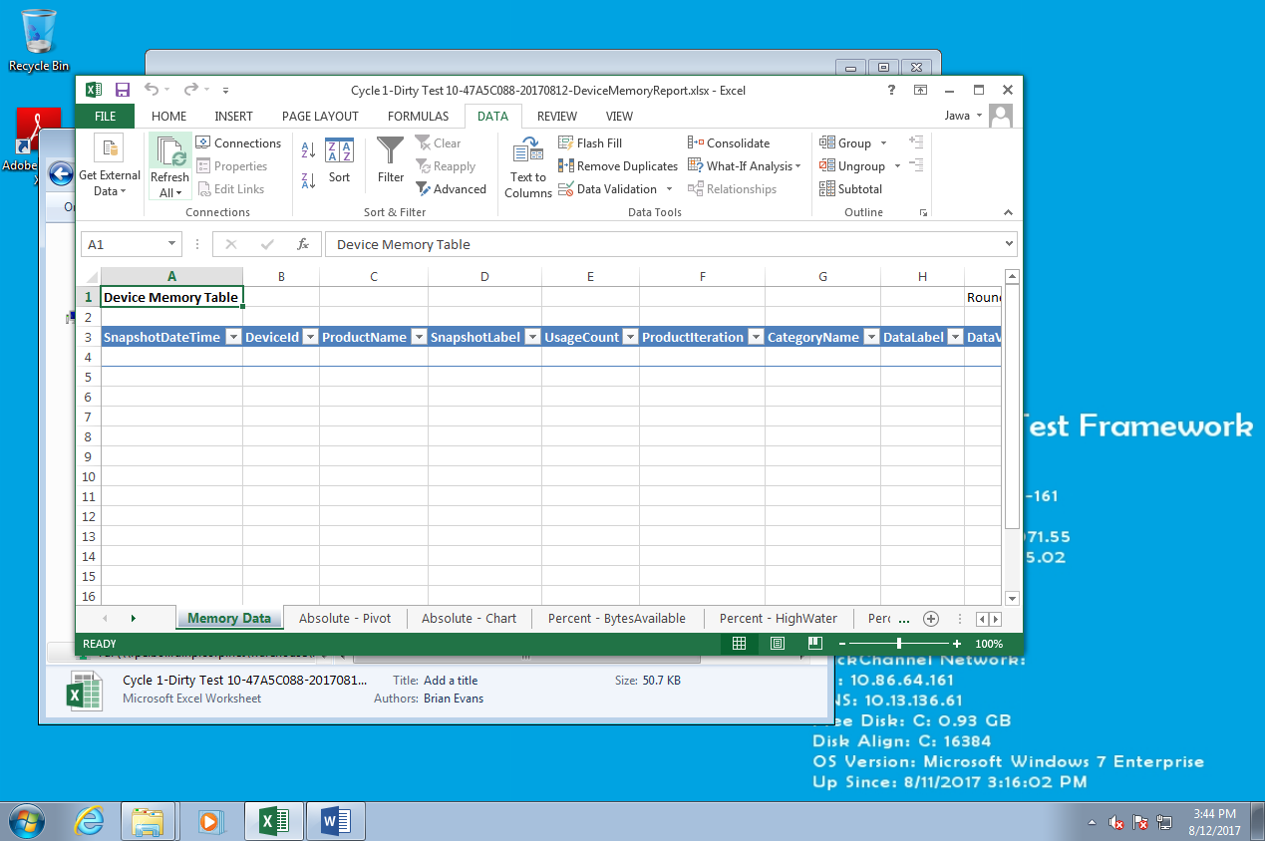
* The data from memory snapshots appears. Note the timestamps that enable you to determine when the snapshots are taken during the sequence of activity:  
  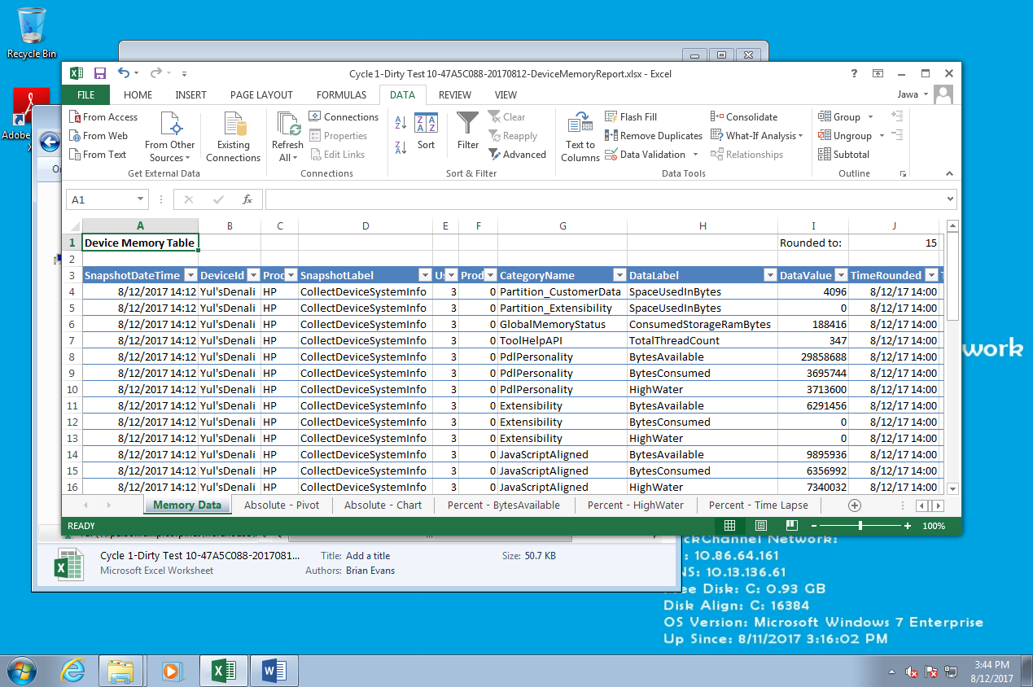
* Use the “Memory Data” and “Absolute – Pivot” tabs to get the values needed to fill in the ACT worksheet at the various steps.
* Use the ACT worksheet to determine if the Solution’s Resource usage meeting requirements (i.e. PASS) or exceeds the requirements (i.e. FAIL.)

# Automated Smoke Testing

Automated smoke testing is not an ACT Requirement. However, many development and test processes include automated smoke testing. Automated Smoke Testing may be used as part of a Continuous Integration development model.

When STB Plugins are available (whether provided by HP or written by the Partner), they can be used to define automated Test Scenarios, which can be run as part of an automated regression or smoke test. The Partner can define which tests to include in a smoke test suite. Typically, these are high level tests. The purpose of Smoke Testing is not to completely or exhaustively test a solution, but rather to quickly verify if the major features are working at a basic level. This type of testing can be used for a variety of purposes, including (but not limited to):

* When developers are making changes or writing new code, they compile and then run the automated smoke tests. The automated smoke tests determine if the changes made by the developer have unintentionally broken some other feature in the solution. This type of test can be used as a pre-condition to code check in or code promotion to main.
* When a build is done, quickly run a set of tests to determine if basic functionality is working. If the tests are carefully chosen, and consistently pass, then a failure typically indicates that something in the build broke and the build must be triaged before it can be distributed or handed off to downstream processes.
* The Quality organization can run automated smoke testing to determine minimal testability of the solution before starting formal testing. Typically, there is a start up cost to beginning formal testing, so smoke testing makes sure there are no major blocking issues that would render formal testing useless. Smoke testing can therefore be used as a gate or entrance criteria for starting formal testing.

# Automated Support for Resource Snapshotting and Memory Leak Test

STB Versions 4.7.5.0 and above have support for Partners to invoke resource snapshotting as part of a memory leak test of embedded clients running on JEDI FutureSmart 3 and FutureSmart 4 devices.

To do so, use the “CollectDeviceSystemInfo” plugin to intersperse snapshot captures of resource usage on the device in between solutions activity.

## Importing Resource Snapshotting Plugins and Scenarios

The CollectDeviceSystemInfo activity and plugin are included in the Base STB distribution, so no import is required. If specific scenarios are provided by HP, import those scenarios using the same procedures explained previously.

## Configuring Resource Snapshotting Scenarios

In the below example, resource snapshots are taken every five pull prints. By comparing resource usage, combined with knowledge of how the embedded solution allocates memory structures, the developer can determine if the resource usage plateaus at an expected level, or continues to grow unbounded over time.

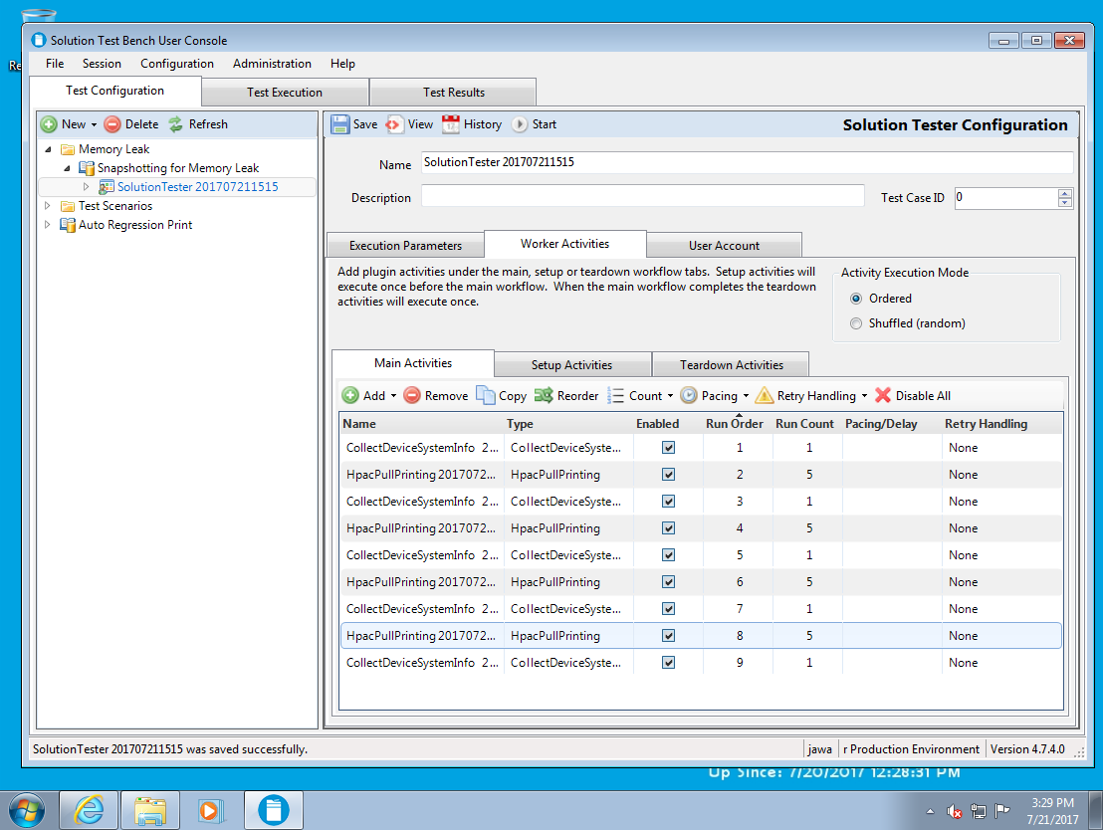

Memory leak testing can be done even if the Partner does not have STB plugins for the solution being tested. Simply substitute manual workflow executions between each invocation of the CollectDeviceSystemInfo activity.

Also, the above set of activities could be further simplified:

* Add the CollectDeviceSystemInfo activity to the “Setup Activities”. This takes a snapshot at the beginning of execution.
* Add just one set of automated solutions activity with some number of executions and one “CollectDeviceSystemInfo” on the “Main Activities” tab (see below):  
  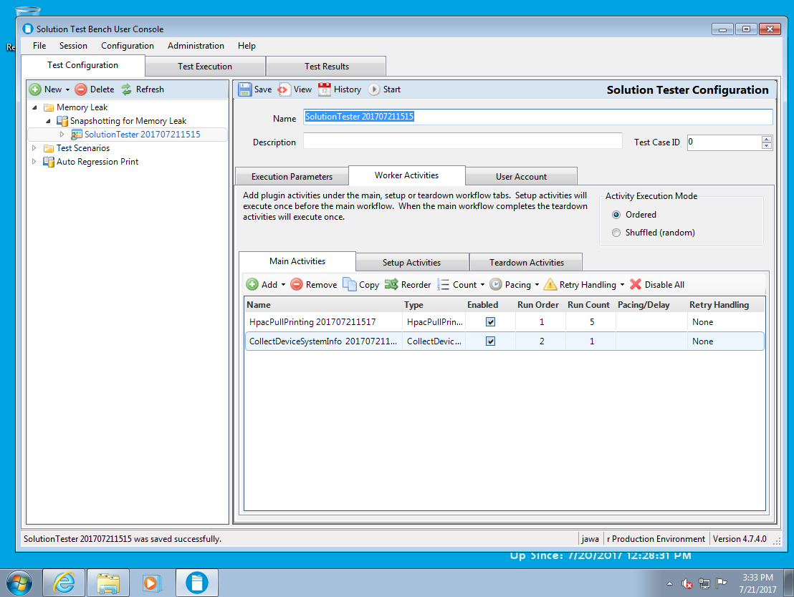
* On the “Execution Parameters” tab, set a number of iterations to repeat the activities on the “Main Activities” tab a desired number of times:  
  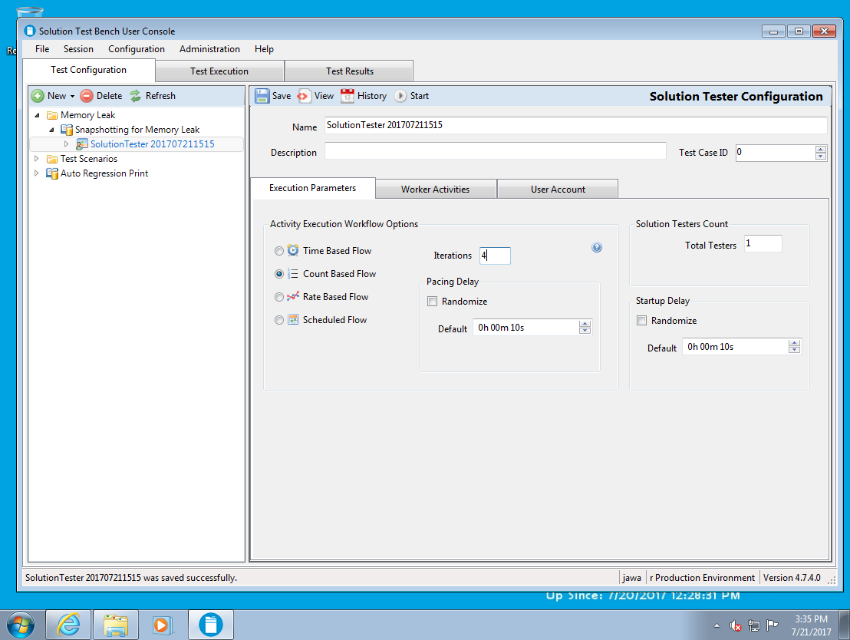

Finally, some HP provided plugins have a set of check boxes at the bottom of the Configuration pane that allows taking resource snapshots at either time intervals or after a configurable number of executions of the activity:

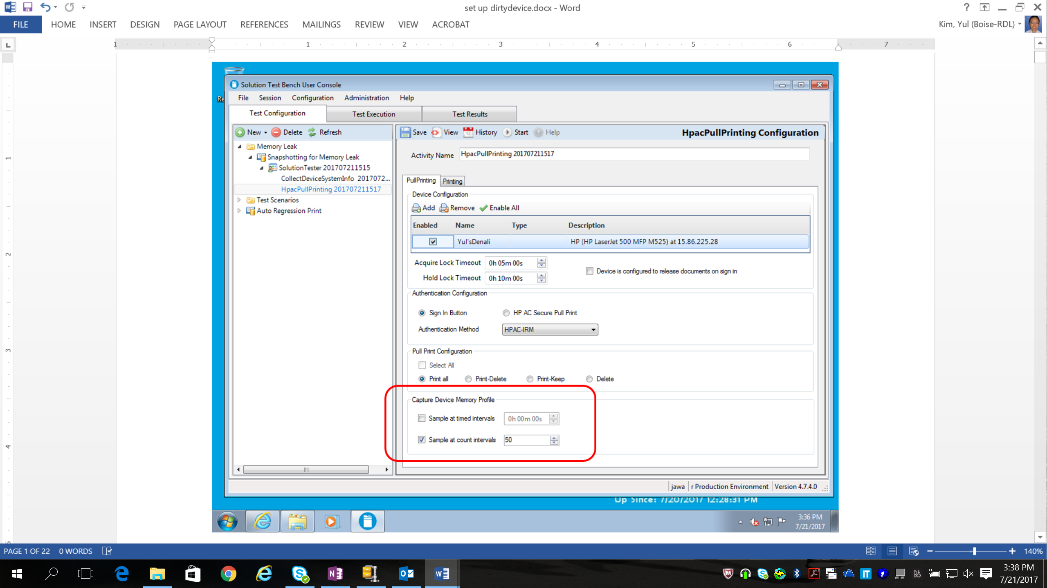

## Executing Resource Snapshotting Scenarios

Execute the desired scenario in the same way explained previously for other types of scenarios.

When testing is complete, use the “Device Memory Report.xlsx” to get the resource levels from each snapshot. The report shows a time index taken from the VM/PC clock which, in conjunction with the “Activity Detail.xlsx” report (which has the same time index), allows the tester to correlate snapshots to the specified test sequence. Again, developers should have an idea of when resource usage, barring memory leaks, should plateau, and can verify this behavior using the above technique.

# Badge Box Support for Automated Card Swipe

HP has designed and built a HW fixture that enables automated Card Swipe called “Badge Box”. The Badge Box is network connected, and has a slot for inserting a USB-connected card reader. The other side of the box has 4 slots for proximity cards.

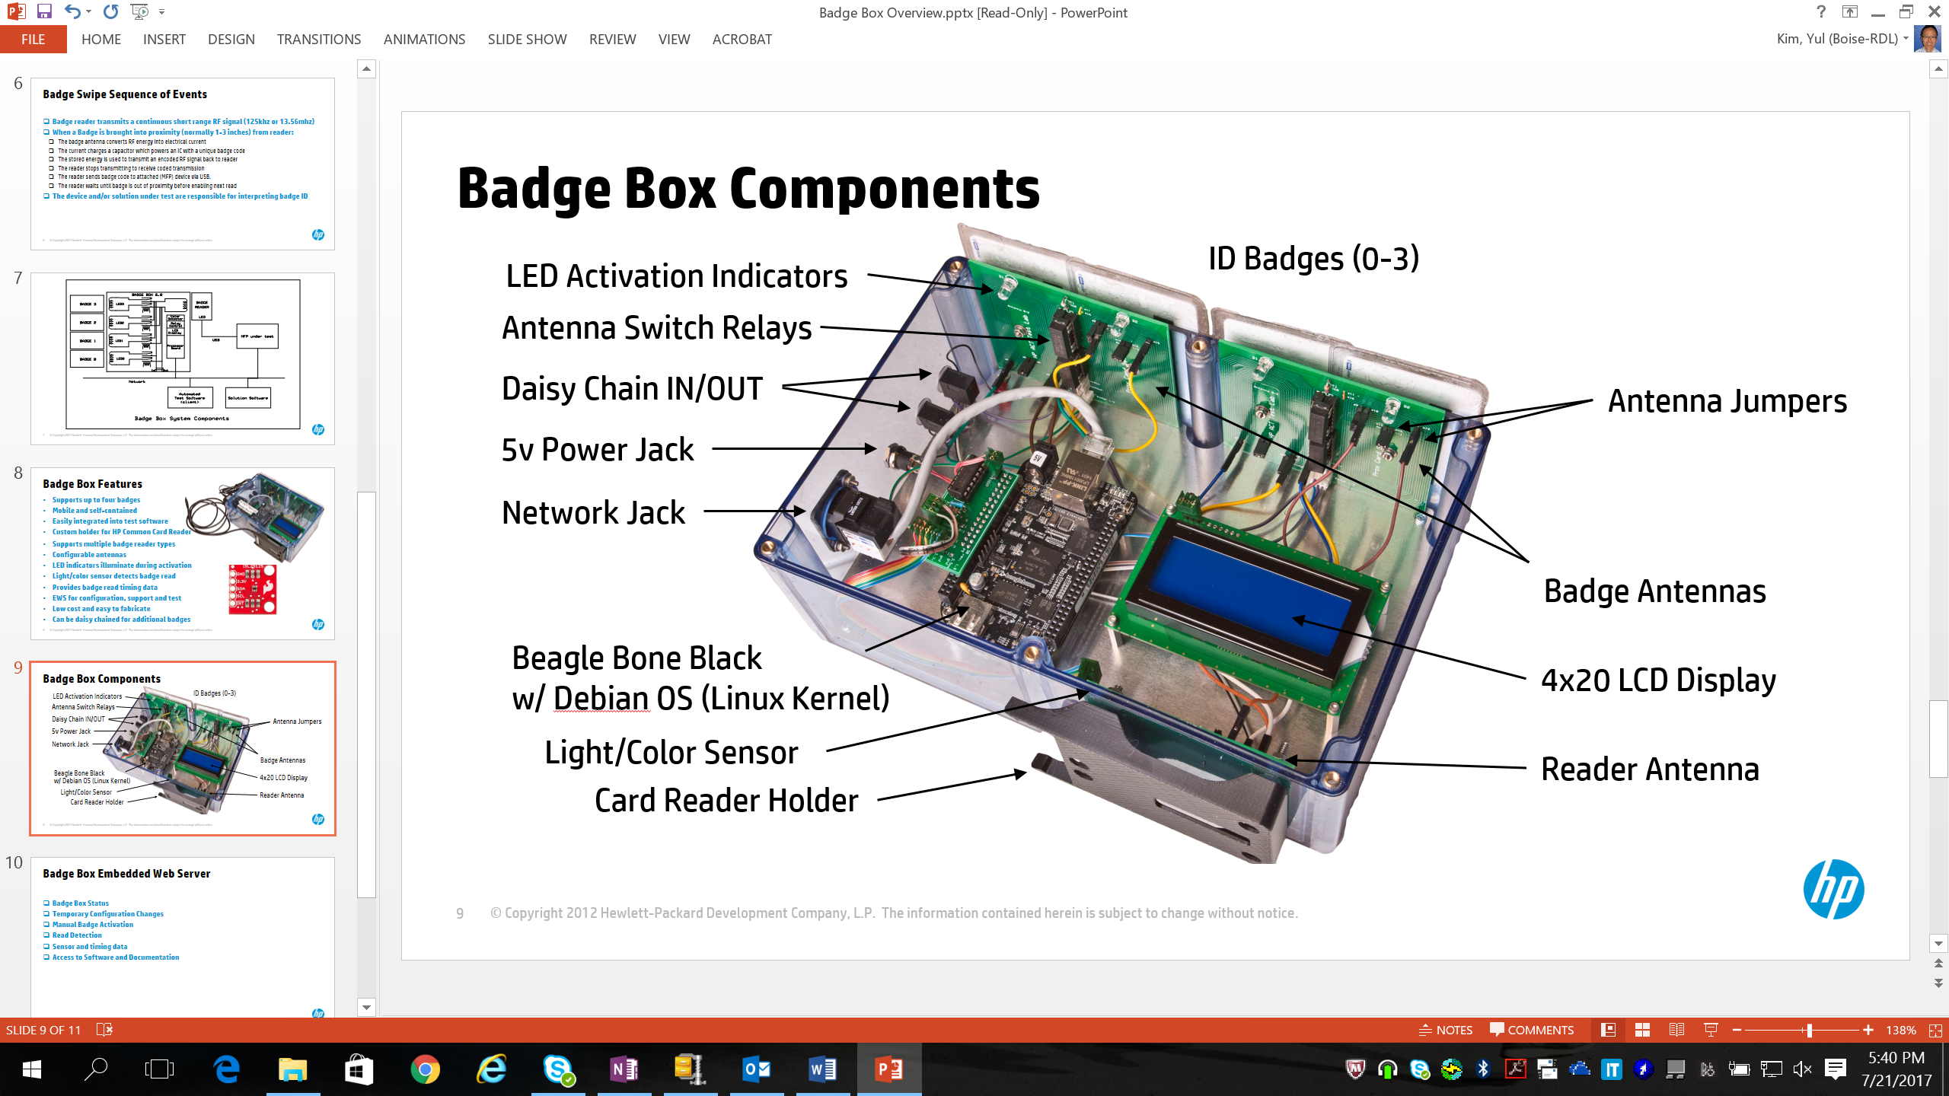

The Badge Box induces card swipes by closing an induction loop between a card reader and one of the four proximity cards. In this way, the energy output of the card reader is transmitted through the induction loop to the card, where it induces an energetic response which in turn is transmitted back through the induction loop and is detected by the card reader:

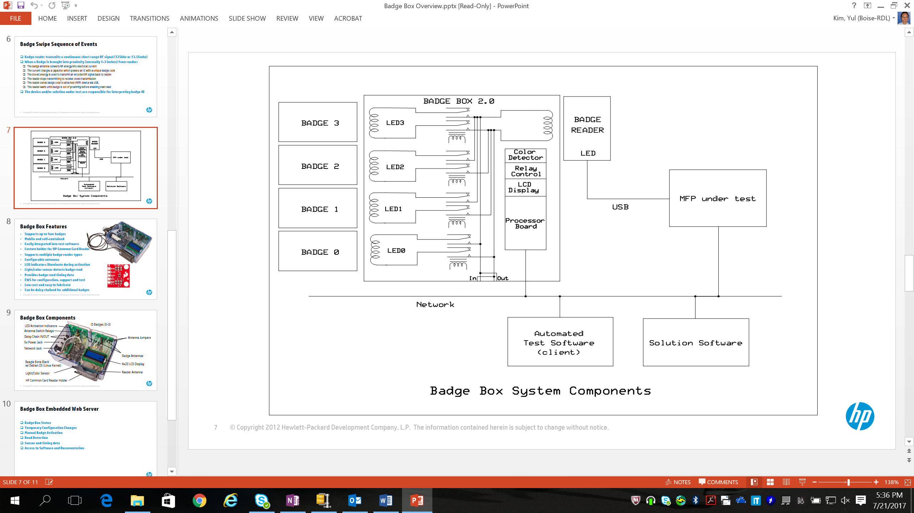

## Importing Scenarios that utilize Badge Box

Plugins and Scenarios for pull printing for HP Access Control, Nuance Safecom, Nuance Equitrac, Pharos Blueprint, and Papercut MF include support for using Badge Box. Import the desired Scenarios and Plugins as explained elsewhere in this document.

## Configuring Scenarios that utilize Badge Box

Please consult the associated documents “Badge_Box_STB_Tutorial.docx” and “Badge Box Quick Setup Guide.docx”.

* At a high level, the required steps are:
  + First, add the Badge Box to STB by using the “Badge Box Inventory” link in the STB Admin Console (after the Badge Box is connected to the network and powered on.)  
    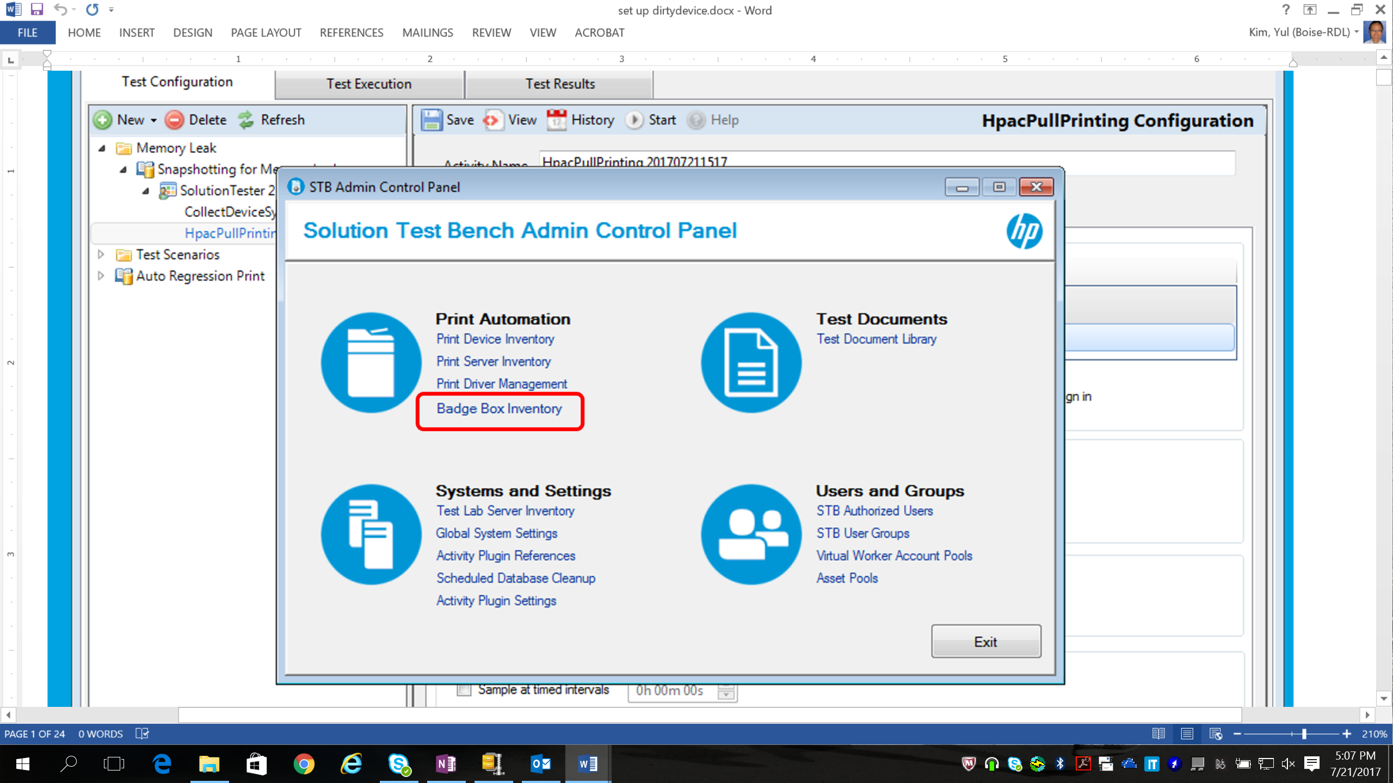
  + Several plugins are coded to integrate with the Badge Box. If so, the plugin will allow the tester to specify “Proximity Card” as the authentication method (see example below).   
    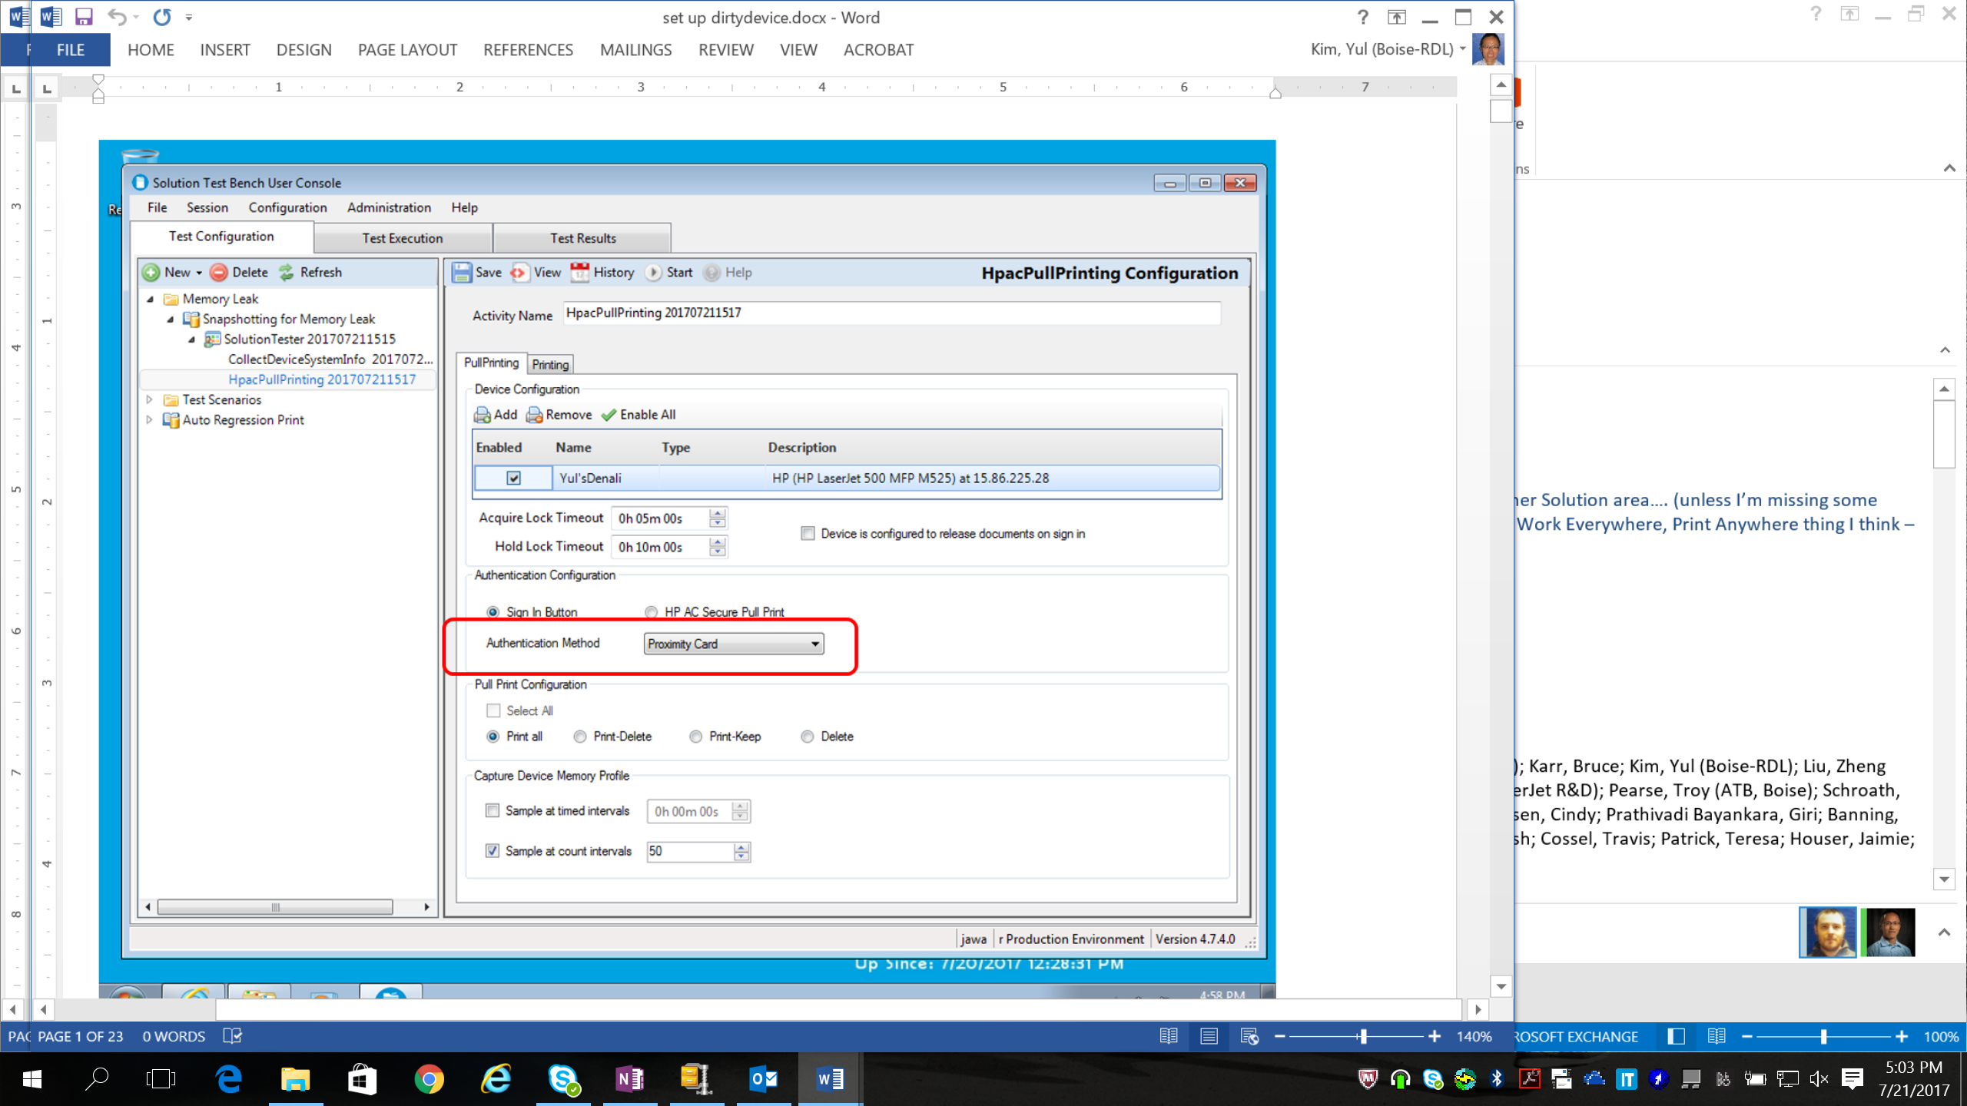
  + Note, the tester must configure the solution so that the card credentials are tied to the desired user. Typically, this is done via a User Pool of 4 or fewer members, where the user names from the User Pool are added to the Solution and one proximity card is associated with each user. In this way, when STB wants to authenticate a user from the User Pool, it will invoke a card swipe of the associated card for that user through the Badge Box.

## Using Badge Box without STB

Badge Box may be used without STB. The Badge Box has an Embedded Web Server.

* + Connect the Badge Box to the network and power it on.
  + If the network supports DHCP, the Badge Box will obtain an IP address and the LCD display will show the assigned IP address.
  + Point a browser to the IP address.
  + Using the various tabs of the EWS, get the API specification and support documentation.
  + Use the EWS to configure the badge box.
  + Several endpoints are exposed at the Badge Box’s IP address that can be called from proprietary SW to invoke card swipes.

# Automated Performance Test

## Performance Metrics Support in STB

STB is plumbed to automatically collect performance metrics for Authentication and Pull Print tests.

Scan performance metrics are being added and will release in a future release of STB.

Partner written plugins can define performance markers, which are points in the flow of activity of interest. Please see the “STB Plugin Developers Guide” for details on how Partner written plugins can defined their own performance markers. Once a set of markers is defined, as those plugins are used to run STB test scenarios, time stamps for each of the markers are stored in the STB database. After test runs, the Partner can extract those via the STB Excel reporting mechanism.

## Performance Reporting

After executing a scenario, use the STB reporting mechanism. With the “ActivityDetails” report, there are a variety of ways to extract and display performance data.

NOTE: within the Excel report, on the Data tab, you can use “Connections” or “Queries & Connections” (depending on your version of Excel) to customize the SQL queries to extract data from the STB database. Right click on the query, and display Properties, then the “Definition” sub-tab. See the example below:  
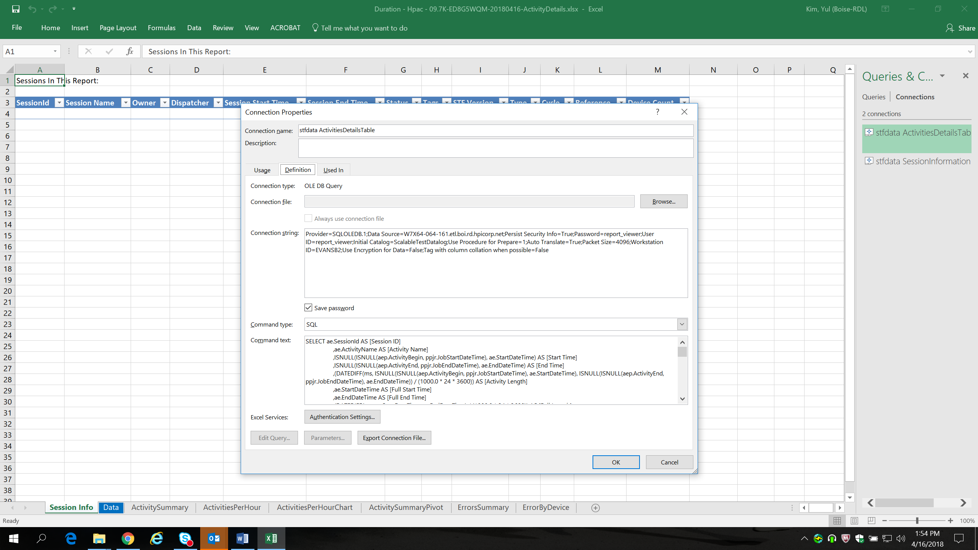

Depending on your version of Excel, you may have to check the following items:

* The STB reports should be supported on all versions of Microsoft Excel from 2010 and newer.
* You may have to click the button “Enable Content” when the report is opened.
* We’ve seen several times that you might have to click the “Data” menu, “Refresh All” more than once. If a tab appears to be empty of data, please re-select “Data” 🡪 “Refresh All”.